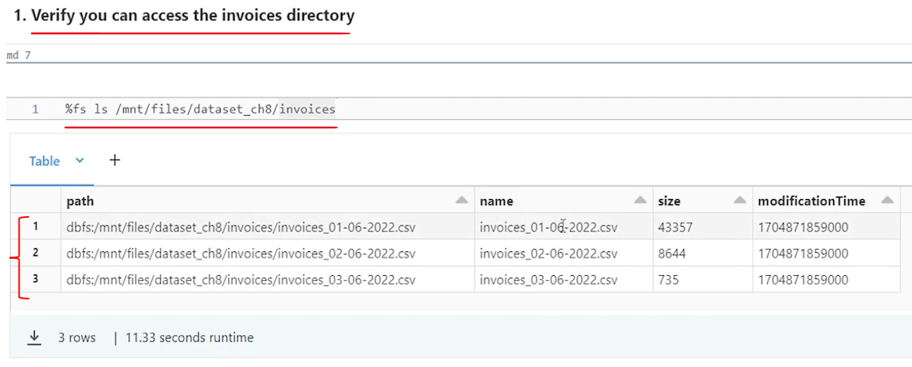

So that's what we are going to do. but this time we want to implement automatic schema evolution. So the idea is to define our bronze layer table without any schema. We want to create a bronze layer table with no schema defined initially. And let automatic schema evolution take up the schema based on the data files and create the table schema. Right? So how do we create a schema less table? In Databricks, we want to create a schema less delta table in Databricks. How do we do that? Super simple.

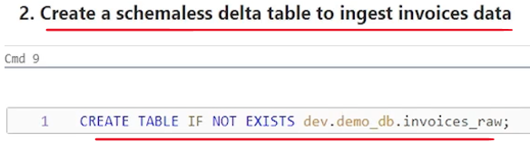

Here is the command create table if not exist table name. That's all we are not defining. What are the columns. What is the schema of the table. So let me run this. And this command will create a schema less delta table. maybe you can describe the delta table and see what is there. Right. So let's say describe. And let's say, extended. And tell the table name. So. Describe extended gives me all the details about the table, but no in schema, right? So we don't have any schema column names, data types for the column names. All those details are not there, but we have a table in the dev catalog in the demo DB database. And this is the table name. And it is a managed table.

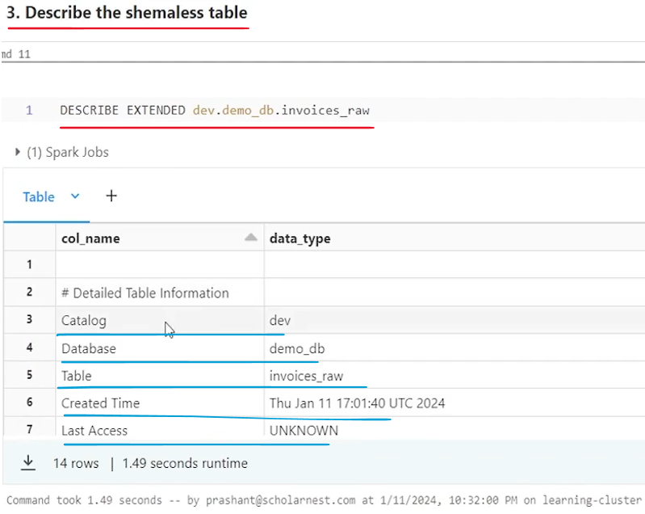

So we have the table in place. It's a schema less table. What we want to do next ingest data using the copy tool into this schema less table from the landing zone directory. And the schema of the table should be automatically defined based on the incoming data. Right? So that's what we want to do. Let's try creating a copy into statement for that. So what we want to do. Copy. Into and just paste the table name copy into this table and then we tell copy from where. So from and what is the from. In the earlier scenario we created a select expression because we wanted to define a select expression list of column names from a landing zone directory. But this time we don't want to define a complete Select statement. We just want to define the. This is my directory. This is my landing zone directory. Just pick up data from there. Whatever files are there, pick up it from there and build the schema at the runtime based on the data files. So I'll simply tell the location from this location without the select expression. What is the location? Location is my. Landing zone directory. So. From. Dislocation. Simple. And then we tell what is the file format at this location. So we say file. Format equal to CSV. And now we can specify format options. So let's say format. Options. What all the options do we want to. Specify I obviously want to tell header is there. So let's say. Header equal to. True. That's there. What other option I want to tell, since we didn't define a schema for the table, and we are not telling what all the columns we need to select. So I also want to leverage the power of schema inference. So I tell infer schema equal to true. So we want to infer the schema from the data files. So infer a schema equal to true. What other options, I also want to tell merge schema is equal to true. So I'm telling the data frame reader the CSV data frame reader to merge the schema. If different file comes with different schemas, maybe some file. One file comes with a five columns. The next file comes with six columns. So one additional column we want to tell the data frame reader or CSV reader behind the scene to merge the schema of different files.

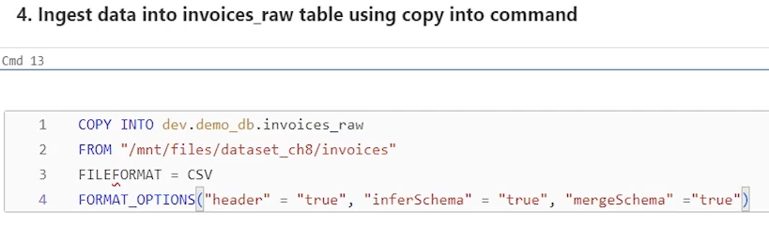

What else we want to do? I know I'm going to get some, timestamp fields in my source files, and those timestamp fields comes with a specific timestamp format. So I also want to tell what is my timestamp format. Timestamp format in my incoming files equal to what is the format? I know my data is coming with d-M-Y format and H.m. That's all. I don't have a second. So that's all about the format. what else.



So copy into also comes with copy options. So in copy options we don't have too many things. But one basic thing I want to tell the copy into command is that we want to implement automatic schema evolution. So if you get some new fields new columns in the data source, create those columns, create those fields in my target table. If the field does not already exist, so that you can specify using copy options. So let me specify that as well. Copy. Options. And I just want to tell one copy option merge schema equal to true. So basically it is the same kind of option merge schema equal to true. That's all. So that's my copy into command with automatic schema evolution configured. So what we are telling copy into this table, read data from this directory format of the data files in this directory is CSV. Apply these CSV options and enable. Automatic schema evolution for the copy into command. That's all. Let's run it

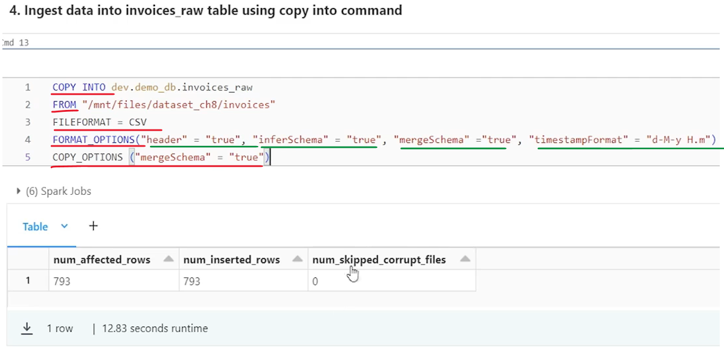

So it worked, and I ingested 793 records into a schemaless table. But what is the schema of the table? That is, schema is determined based on the input data set. And since I have implemented automatic schema evolution using this option, the copy into will add the columns into the table.

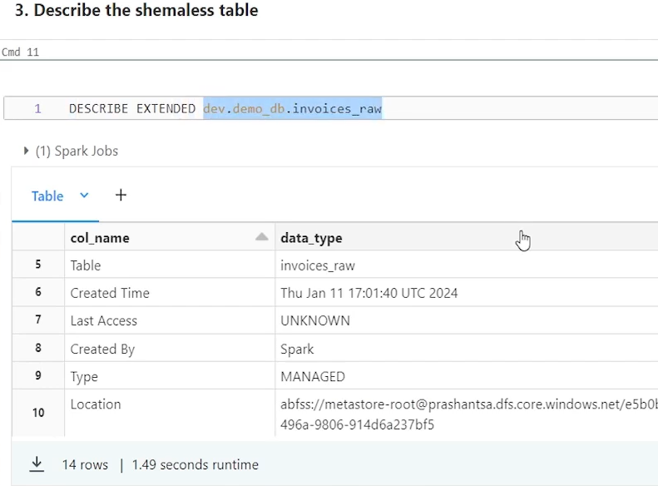

Let's let's check what do we have in the table. So we got 793 records. all looks good. Customer ID is null for some records, but that's how data is in my files.

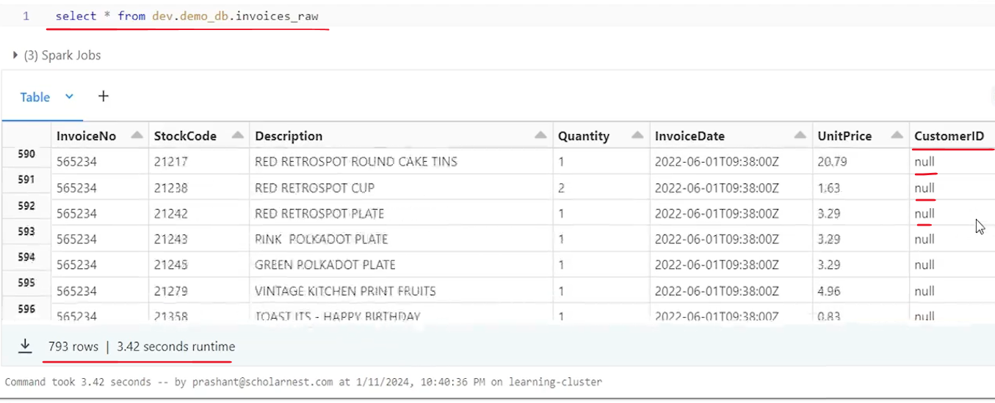

Some records come with null customer ID, and later, some record comes with the valid customer ID. So data is inserted into the table and I can see fields also if you want, you can, describe your table. Right and see what do we have? in the schema. So invoice number is now integer. It's inferred automatically.

|  |  |
| --- | --- |
|  | That's how the schema inference works. it found that infer schema option has found that, invoice number looks like an integer. So integer is a string. A string int for quality time is time for invoice date double for unit price, int for customer ID. So few hiccups here and there in terms of automatic schema inference. but that's how it is. So We are done ingesting data into our schema less table using automatic schema evolution in the copy into command. That is how copy into automatic schema evolution works.  But let's, progress the scenario. Let's ingest one more data file, into our landing zone. I'll copy one more data file into the landing zone, and this data file comes with one more additional column. So we get. Country column in this new file, which is extra, which was not there in the earlier. So how copy will work now ingest data into invoices_raw table again. So same copy into command should work without any changes. So let me copy it here. And run it again. So it worked. 254 records are inserted once again. if you want, you can. Do a select star on that table once again. |

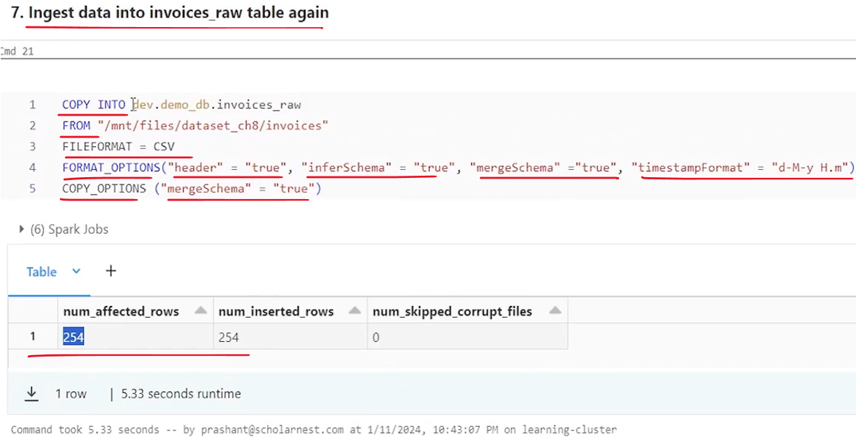

|  |  |
| --- | --- |
|  | And check the records. So. We got country column at the end. some records are null, which are old records, and new records has got the country field value populated. if you want, you can describe the table again to check how the schema evolution has worked. let's say we want to describe the table.  And you can see, we got a new column at the end, which is string inferred as a string. So that's all, for copy into with automatic schema evolution configurations. And you can use it if you have a requirement where you want to keep on ingesting new, new fields as they arrive into the data ingestion pipeline. And without breaking your copy into command, you keep on ingesting and keep on evolving your schema automatically. |

### Streaming Ingestion with Manual Schema Evolution

we will learn to use Spark Structured Streaming API for. Data ingestion into our bronze layer from a landing zone directory. And we will learn how to implement manual schema evolution approach for spark structured streaming data ingestion. So let's start. As usual, I'll go to my workspace. open a notebook that I have set up for you.

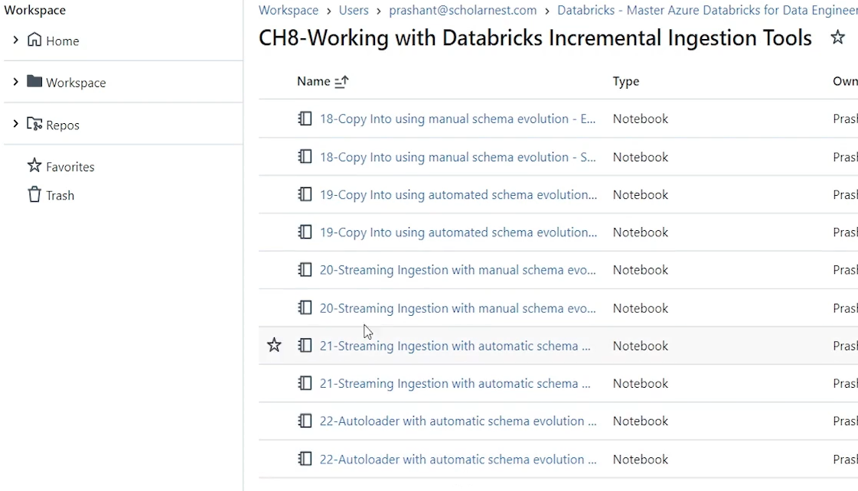

And connect the cluster. Do some cleanup.

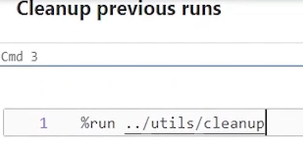

And then do a setup.

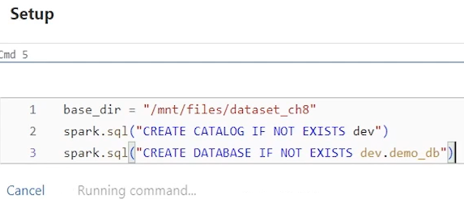

So basically I'm creating Demodb database in the dev catalog and also setting my base directory location. So this is the base directory location for this demo. Now since we want to implement data ingestion scenario from a landing zone. So I have set up a landing zone directory. Let's see what do we have in the landing zone directory.

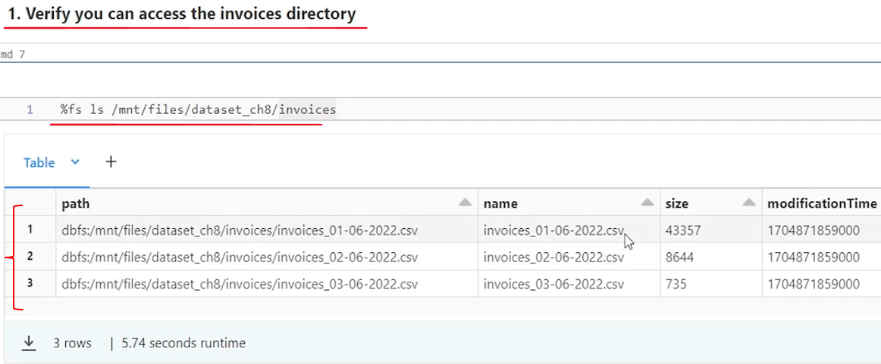

|  |  |
| --- | --- |
| So we have three data files in the landing zone directory. we are assuming that these files are ingested by my ingestion tool and placed, in the landing zone directory. And we want to write spark structured streaming code to ingest data from this directory, from these files into my bronze layer table.  And we want to use manual schema evolution. So I want to create a bronze layer table with a fixed schema. So I have code written here for my bronze layer table. So let me run this and I'll create a bronze layer table with a fixed schema. It's like invoice number is int a string a string int timestamp double int. That's how we assumed my, invoices_raw table should be. |  |

So this is the table. And then since we want to use Spark Structured Streaming for ingesting data, I am making an assumption that you already learned Spark Structured Streaming. You are familiar with the API. So I'm not going to, explain that, but I have a function here. this is my spark structured streaming, code function.

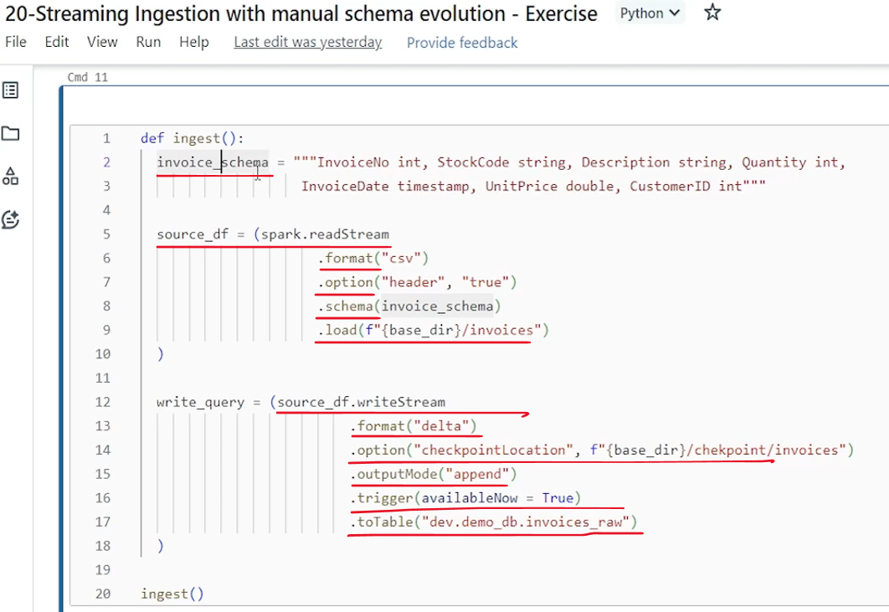

So I have a function here in just function. I have defined it using a spark structured streaming code to read data from a landing zone directory, create a streaming data frame, and then without making any modification, without applying any transformation, write that data frame into the. My target bronze layer table. That's what we want to do. So simple function. I define a schema because I don't want to go for a schema evolution automatically. So I want to make sure that I fix the schema for my ingestion pipeline and my, bronze layer table. So I define a schema here, which matches with the table, schema and my data file also. So we have invoice number, stock code. All these are, defined. And then I'm using a spark dot read stream to read data as a stream and create a streaming data frame. format is CSV header is true. schema is defined here. So we want to use that schema and read it from my base directory slash invoices which is my landing zone directory. Create a data frame and then use that data frame to write the stream format should be delta. And this is my checkpoint location. I want to use append mode and we want to use available now trigger only. We want to run it as a single micro batch for all the data files that are currently available in the landing zone and then stop. We don't want to keep on running as a continuous, series of micro batches. We are just simply testing it. So I want to run it as a single micro batch for. Available data and then save it to a table. This is our bronze layer table. So function definition. And here from starting from here it ends. And then I'm also making a call to the function. So let me run that. Once I run it my data for the current files should be ingested. So it's running a stream. Our Stream is finished.

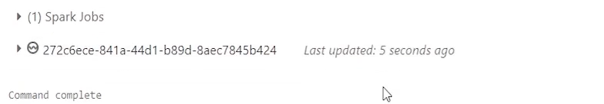

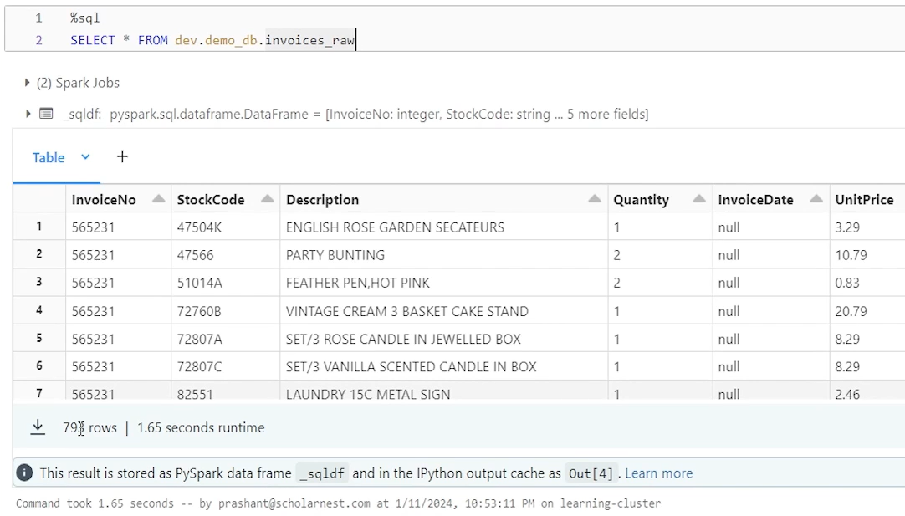

Hopefully my data is ingested, so let's. Try querying the table and we saw 793 records. That's what we have in our, three data files that we ingested. Right. So we got the data. Data is ingested. And now let's move on to the next step of this scenario. Let's say your ingestion tool ingested some more data and saved it in the landing zone as a new data file. So to simulate that scenario I'm copying this data file into the landing zone directory. true. So it should be copied there. Now what if I run my ingestion code once again?

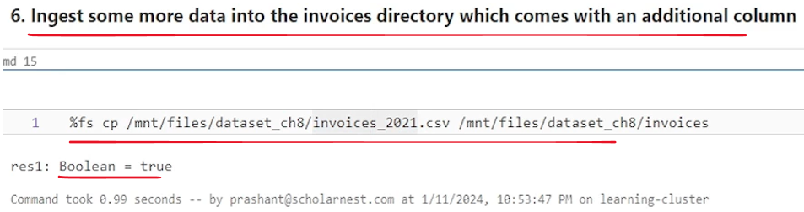

I mean, if I run this ingest function once again what will happen are your ingestion code will not break, but it will silently ignore the additional columns. If we have some additional columns ingested into this new data file.



So I purposefully designed this file with one additional column. So this data file comes with one new column country column one additional column which is not there. so if you have a requirement where you don't want to, ingest new columns, ignore them without breaking your, data ingestion pipeline, you don't have to make any changes. Keep on running your pipeline, let new files bring new columns, but we keep on ignoring them. If that's the requirement, you are good. But if we have a requirement to incorporate those new fields in our bronze layer table. So we will have to do two things. First, evolve the schema. So we will have to evolve our table schema add new columns. And then second we'll have to tweak or modify our ingestion pipeline so it identifies the new columns and start incorporating them also from the next run. So we'll do it in the two steps. The step one is to evolve your schema using Alter Table, it's a manual evolution. I am adding one more column here. I've executed it.

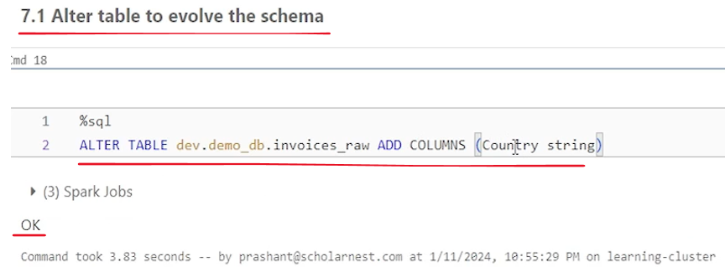

So it worked. And then same code. Actually I copied it. but we are making a modification in this code to incorporate the additional field. And the only change is here I, I added country string, at the end, because that's the additional column coming in and rest all remains the same.

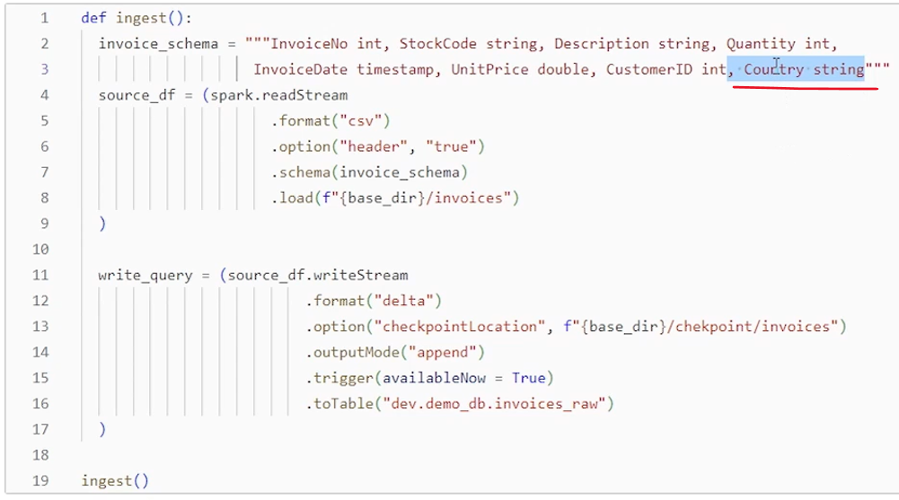

We still use the same read stream format CSV header, true schema. We pass the modified schema, read it from the landing zone. All here remains the same. The only thing is we want to include country column also. So we modify our schema to include the country column. And if you want you can run it again. it will start a new stream. One micro batch of the stream, ingest new files. Only because we know that spark is streaming, by default. Is incremental processing, right? It will process only new files. So we ingest new files. And after that, if you want, let's check the, table.

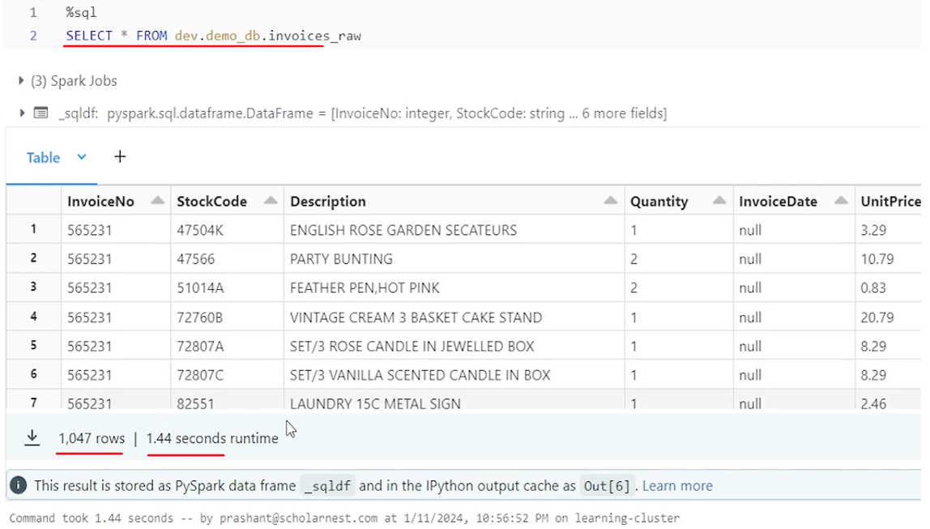

And we have 1047 records. and that's as per my expectation. So we ingested new records as well. That's all for this lecture. So in this lecture we will learn how you can use Spark Structured Streaming to ingest data from a landing zone and bring it into your bronze layered tables. And how you can implement manually schema evolution with spark structured streaming.

### Streaming Ingestion with Automatic Schema Evolution

We will learn to use Spark Structured Streaming API for ingesting data from a landing zone. We want to learn incremental ingestion from a landing zone or from a cloud directory using a spark structured streaming and ingest data into our bronze layer table. But we want to also implement automatic schema evolution. So let's get started. As usual, I'll go to workspace and show you one notebook where I have set up a code for this demo and connect a cluster.

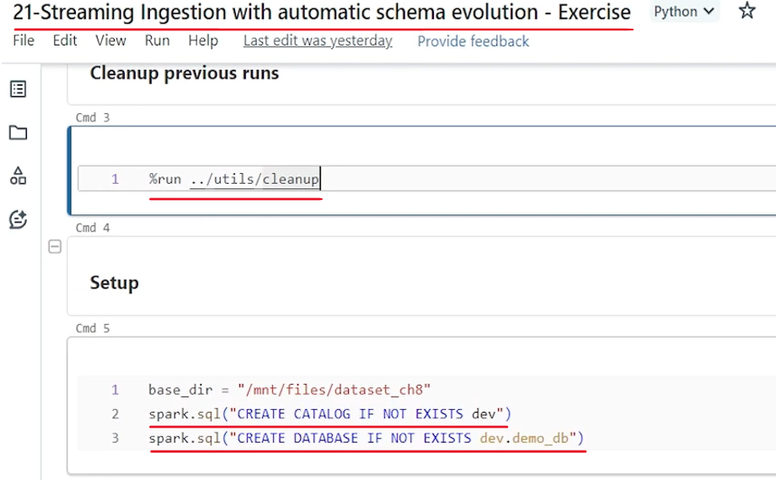

Do some cleanup. And then also do some initial setup. So that's all. we want to learn how to ingest data from a landing zone.

So we need to have a landing zone directory. So I have simulated this landing zone directory here. The directory name is invoices. And I'm assuming that we ingested three data files. So my data ingestion tool is ingesting data from source and saving it as data files in the landing zone.

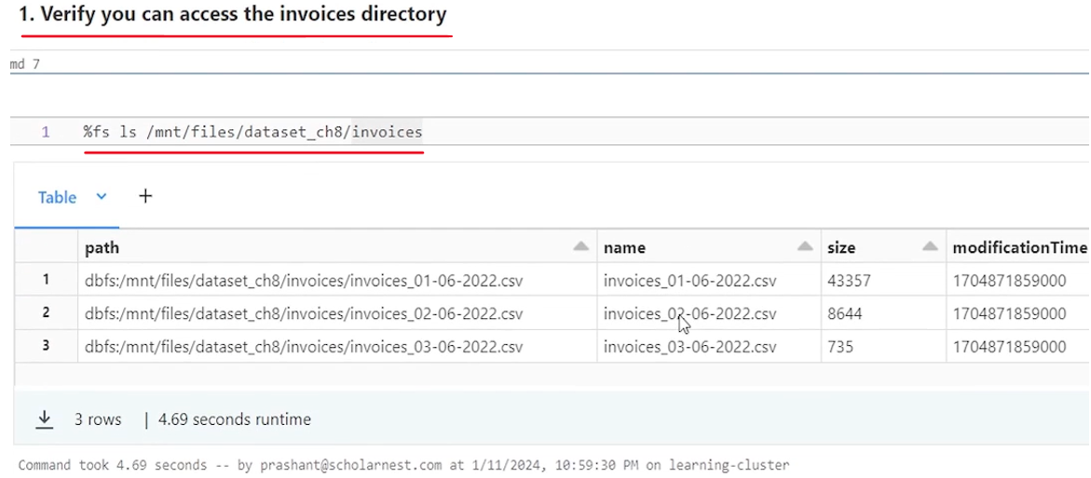

The file format is CSV. And as of now we have ingested three files. So now we want to build code to ingest data, these files from landing zone and build our raw data layer, bronze layer table and load this data into the bronze layer table. How to do it using spark structured streaming with schema evolution automatically. So so I have set up a code here. basically I want to create a ingest function. inside the function we want to implement a spark structured streaming for reading data from the landing zone with configurations necessary for implementing automatic schema evolution. So let's see what do we have. So first thing is to set this configuration spark SQL streaming schema inference. we haven't created our A table and we are ingesting data from a CSV file. So we want to implement a schema inference automatic schema inference for the CSV file. But for spark structured streaming schema inference is disabled by default. It doesn't allow you to infer a schema. So if you want to. Allow a spark structured streaming to infer a schema from the CSV files. I'll have to set this configuration to true. So that's what I'm doing here. And then rest is simple.

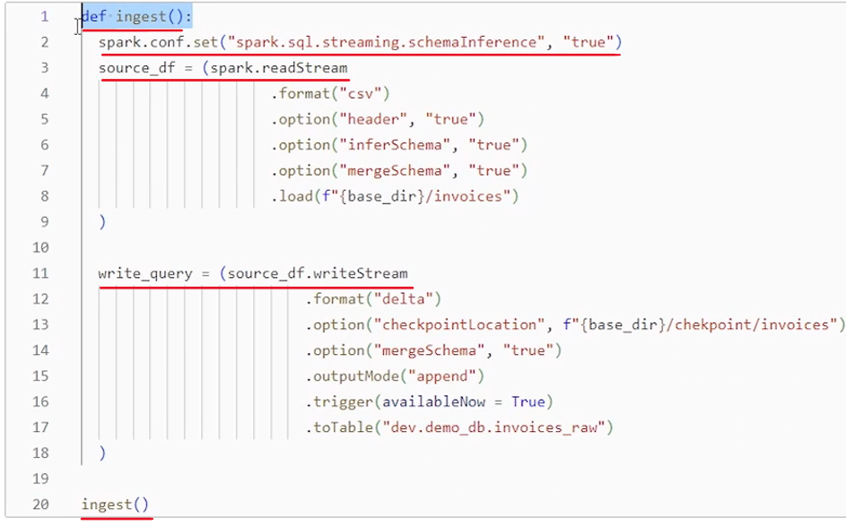

We are using a spark.readStream to read data from a landing zone. This is the location. We want to read it as a stream and create a streaming data frame. Format is CSV and since CSV file comes with header, I'm specifying header is equal to true. And then we also want to infer a schema automatically from the CSV file. Right. So I'm setting that infer schema equal to true. And we want to make sure that we are able to read data from the files even if two files have different schema. So I'm setting this merge schema option to true. This merge schema option is for the CSV reader, which will allow CSV reader to read two data files, even if there is a difference in the schema in those two data files. So that is the reader option. And read it from the landing zone. Create a streaming data frame. Once we have the streaming data frame we don't want to implement any transformation, any logic there. The idea is to load the raw data as it is into the bronze layer table. So next step what we are doing taking this streaming data source and using writeStream and all the automatic schema evolution is implemented at this place. Right. So we want to write this stream as a delta table into this table at the end. Invoice is raw. That's my bronze layer table and usual options. since I'm writing a stream, it is always advisable to, implement a checkpoint so you can restart from the same point. So this is my checkpoint location and set the merge schema option while writing the stream. So this is what, enables the spark structured streaming to automatically evolve the schema of the target table.

This is my target table. So if target table doesn't have those fields which I am ingesting, the writer, the stream writer will automatically add those fields into the target table. So setting this will enable my automatic schema evolution. Output mode is append and we want to trigger the available now for only those files which are already available in the landing zone at the time of starting this streaming query. run only one micro batch and stop. And then we will schedule this function to run at regular intervals, maybe every five minutes, half an hour, depending upon our requirement. So that's all. Let me run it.

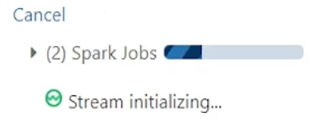

And I'm making a call to the ingest function that I defined here. And once it runs, I should have data loaded into my target. bronze layer table. So let's see. It worked. Now if I go and check my bronze layer table, I should have data. I have loaded 793 rows. That's what I have in my data files. So we are done with the first iteration.

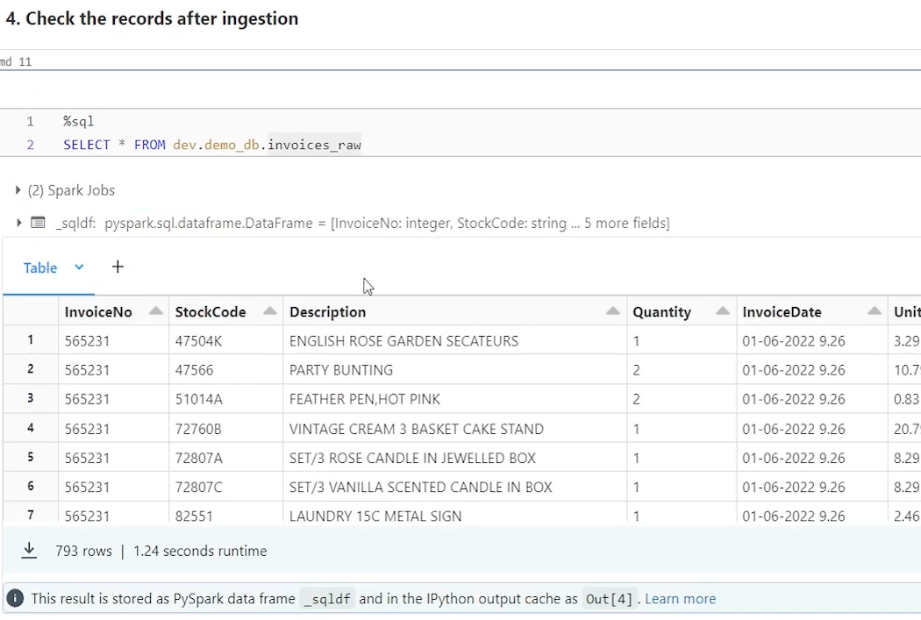

Now let's assume in the second iteration we ingested some more new files. So I have simulated that scenario. Also, I am copying one additional file into the landing zone directory to simulate that my our data ingestion tool has ingested some new data into that directory. But this new file comes with some additional column. So in this file we have one new column coming in.

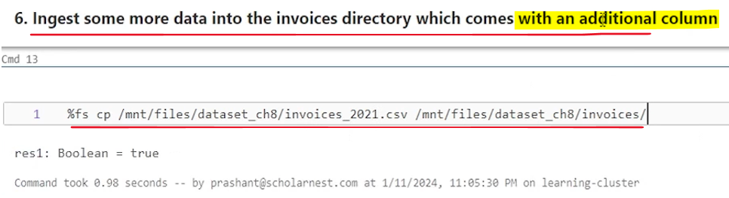

What do we want to do. We want to implement automatic schema evolution. we want to keep on ingesting whatever new fields are coming. Keep on automatically evolving our tables. So we are already configured for all that. So there is no code change required. Nothing. All I have to do is to call the same ingest function that I defined earlier and executed earlier. So. I'll simply call that function. No code change is required. Nothing. It will work and in just the new field also. So it's done. Now, if you want to see your table, after the ingestion, just look at it. We have a country column here. in the earlier ingestion and the result table, customer ID was the last column. We didn't add country column, but now we got one more column. data is there. Looks null in the beginning, but in the later records we have the data. So data is ingested.

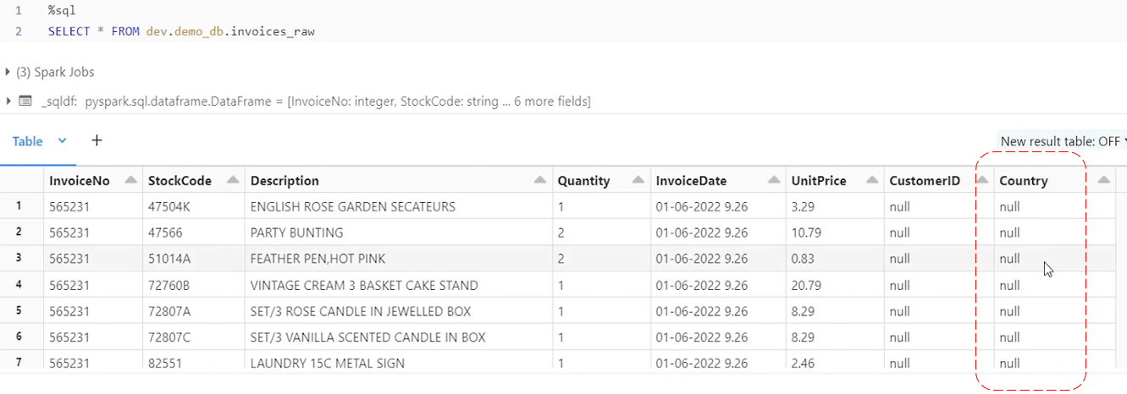

|  |  |
| --- | --- |
|  | If you want to describe your table and see if the schema has evolved appropriately, you can describe the table and see that you have a country column added which is a string.  That's how automatic schema evolution works for Spark structured streaming. |

### Introduction to Databricks Autoloader



Databricks Auto Loader. We'll try to understand what is auto loader, why we use it and what are the advantages of using auto loader. So let's start. So let's start with a very simple question. What is Databricks Auto Loader? In simple terms, auto loader is a framework for efficiently processing new data files from the cloud storage.

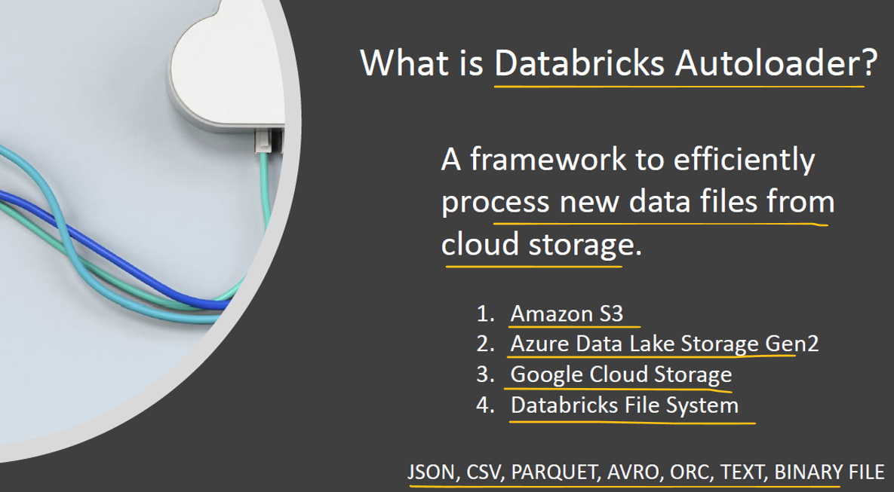

So we use auto loader for ingesting data or reading data more efficiently from the cloud storage location. And it supports Amazon S3, Azure Data Lake Storage Gen2, Google Cloud Storage, and as well as Databricks File System, and it can support various types of files like Json, CSV, parquet, Avro, ORC, text, binary files.

Auto loader is built on top of spark structured streaming framework, so implicitly auto loader is capable of consuming data from the cloud storage in incremental way. We can use auto loader for incremental data ingestion from the cloud storage. Now the next question comes is why auto loader? Why not copy tool or why not directly write Spark structured streaming API and build your solution? There are few advantages of using auto loader. Let's try to understand that auto loader offers you optimized file listing or optimized file read from cloud storage.

|  |  |
| --- | --- |
|  | It is specifically designed and optimized to read data or files more efficiently from the cloud storage. How it does that? They use cloud native APIs for reading data from the cloud storage directories, instead of using generic APIs or generic code for um. Reading data from a distributed storage, which works for all cloud platforms. So instead of that, they have a specialized, cloud native APIs configured for auto loader. Auto loader makes fewer API calls compared to you trying to read directly from the cloud storage using spark APIs. So auto loader will make less API calls, which makes it more efficient. Auto loader also supports incremental listing, so every time listing all the available files in the cloud directory instead of that auto loader goes for an incremental listing, which makes it more efficient. There is an optional feature available with auto loader. |

You can configure auto loader to receive notifications for data landing into the landing zone, or file creation notification. So as soon as new file is created in the cloud directory location. Auto loader can accept notification and process directly only those files without even going for detailed file listing and identifying what files are available in the cloud directory.

So these are the features which makes auto loader more efficient for reading data from the cloud directory. So if you are doing a streaming ingestion you are collecting data and you are collecting it very high speed. You have hundreds of thousands of files being ingested in your cloud location or your cloud landing zone. In those scenarios, using auto loader will significantly improve your performance for reading data from the cloud location. Other than that, there are few other, capabilities added to the auto loader. It simplifies schema evolution and schema management during the ingestion, and it also simplifies and gives some feature for data rescue. So during the schema evolution or schema validation, if some fields, are not captured correctly or cannot be translated into the desired schema or desired format, auto loader captures them automatically as a rescued data field and simplifies your data rescue operation. So that's all about the auto loader. I hope you understand what is auto loader, why we use it. And then in the next lecture onwards we will learn how to use auto loader. We will go through the mechanics of using auto loader.

### Autoloader with Automatic Schema Evolution

We will learn to use autoloader for ingesting data from a landing zone directory and save the results into the bronze layer table. So let's get started. As usual, I'll go to my workspace and I have set up a notebook for you. So let me go to my notebook.

|  |  |
| --- | --- |
|  |  |

Connect my cluster. Do some cleanups. And then also do some setup. So basically what I am doing, I am setting up a dev catalog and a demo database in the dev catalog. And I'm also setting up a base directory, data set chapter eight, where I have some sample data already uploaded. Clean up and setup is done. Now let's look at our landing zone directory. So to simulate the scenario for data ingestion from a landing zone directory, I have created a directory here. The directory name is invoices. I'm assuming that my data ingestion tool is ingesting data and saving that data as data files in this directory. And I want to use auto loader to ingest data from this landing zone and bring it into my bronze layer delta table.

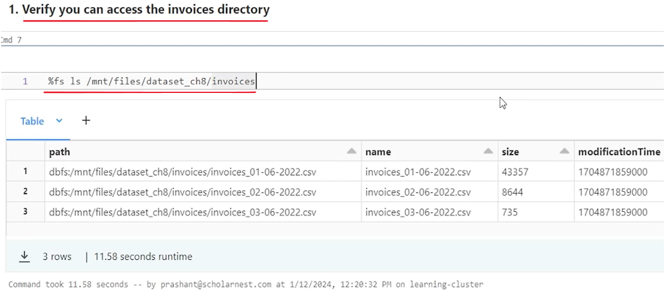

So that's the goal to simulate that scenario, I already have three files, pre ingested in this landing zone. And now we want to ingest data from this landing zone from these files into our delta table in the bronze layer. So we want to learn how to use auto loader for ingesting data from a landing zone into a bronze layer table. And we want to implement automatic schema evolution. So the idea is that auto loader pipeline should keep on running ingesting data continuously from a source directory, into my bronze layer table without breaking. And if we receive some new data, new fields, in my landing zone directory, auto loader should automatically evolve my schema, add those additional fields, and ingest them into the raw layer.

At least we capture the data or new fields in the raw layer. And we decide later that what to do with that new additional fields. going forward, even if there are some fields which cannot be translated correctly or the schema cannot be evolved, we want auto loader to continue without failing and capture those fields. in the data rescue, column of the same delta table in my raw layer, so we can investigate what, data needs to be rescued and work on that. So the point is, we want to write an auto loader script or, command, configure auto loader for continuous data ingestion from a landing zone directory without failing. That's the goal. So how do we do it?

Let's start with defining a function. So I want to create an function. Let's call it ingest function. And I want to write a script using autoloader tool. So what is auto loader? I hope you already got some idea that auto loader is a framework, and it is built on top of spark structured streaming API behind the scene. It uses Spark Structured Streaming API, and it is available to us as a framework, as a API or as a connector. So it's not a UI based tool where you can drag and drop and design your data ingestion from the landing zone. We will have to code and the code looks like spark structured streaming code. Basically, we are going to write a spark structured streaming code for ingesting data from the landing zone. But we will be using auto loader for, streaming ingestion. So let's start writing the code. I hope you already know how to write spark structured streaming code. So basically I will use a spark dot read stream to read data from the landing zone, create a streaming data frame, and then since it's a raw layer, data need to go into the bronze table. We don't want to make any transformation, any changes. We capture whatever is coming and without any transformation, write that streaming data frame into the bronze layer table. That's what we want to do. So let's define a. Data frame, and I want to use, a spark dot. Read a stream for reading the data from the source. And then, what do we need to tell next? The next is we need to specify the format. What connector do we want to use for reading data and creating a data frame.

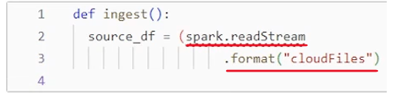

So usually we specify connector like CSV or Json or Avro parquet Delta right. But in this case we want to use auto loader and auto loader connector is available to us as cloud files. So. Let's say connector is cloud files. let me put up a parenthesis here so we don't, get line continuation error. And we'll write code inside this parenthesis to create a source data source data frame. So I have told the, connector connector is cloud files, which means connector is auto loader. Auto loader is available as cloud files connector. And then what is next. We still need to tell what is the file format right. What is the data file coming as. So data file is coming as CSV. in my example my data files are CSV files. So I have to tell that and how to tell that we tell that as an option. And for that I have to use cloud files option. So it comes like let me copy this cloud files. Dot format. And that format is going to be CSV. Right. So basically we are telling that use the cloud files connector. And then we are configuring Cloud Files connector and telling it that the data file format is CSV. Right. Instead of using CSV connector we are using Cloud files connector which is autoloader. So we are using auto loader and then configuring auto loader with the file type. So that's done.

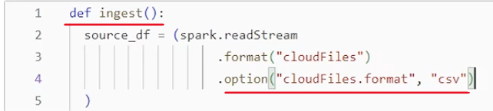

Now once we configured the cloud files connector with the file format we can again start using CSV options. If we want to specify some additional CSV options we can specify those. So let's specify some CSV option I know my data file is coming with header. So I want to set header equal to true. And that's done. I also want to specify timestamp format because my data is coming with a specific timestamp format. So, Timestamp format and the format is d, m, y, h and minute. That's all I have in my, file.

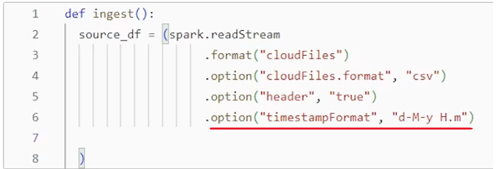

We are reading data from CSV files, right? And we haven't created any target delta table yet. So what we want, we want our auto loader to read data, infer schema from the CSV files, build a schema target schema for the target table, and impose that schema into the target table. Create the target target table with the desired schema. So basically we want auto loader to infer a schema from the data source right from those data files. by default auto loader will infer a schema. We don't have to specify additional option for that. But auto loader will automatically infer everything as a string. It won't try to infer the correct data type. So let's give an option. We don't want that to happen. We want auto loader to infer data types correctly. So for that I have to configure auto loader with the cloud files.infer.Column Types and set that to True. So now auto loader will also infer column types from the CSV file. Otherwise by default it will infer everything as a string. Every column becomes a string. We don't want that to happen.

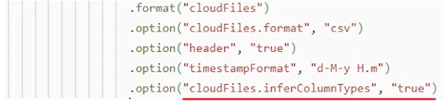

Our auto loader also maintains schema information for simplifying the schema evolution. We know behind the scene. Auto loader works on the spark structured streaming API. So basically this code, this read stream code is going to run as a series of micro batches. Right? So for every micro-batch a auto loader will read data from the landing zone, infer the schema, and want to save that schema at some location so that in the next micro batch it knows what is the schema till the previous micro batch and compare if there is a difference in the schema. Now in this micro batch we have to evolve this schema, right? So for schema management, auto loader needs a checkpoint directory, a kind of checkpoint location where it can save the schema information, during the ingestion, for each micro batch. So we have to give that option also. So that option is. CloudFiles.SchemaLocation and let me copy paste, location that I want. So basically I want, in my base directory, checkpoint directory. And inside that checkpoint directory I want auto loader to create. Invoice is a schema directory and use this Invoice's schema directory for storing and maintaining the schema information across all micro-batches. So that's done.

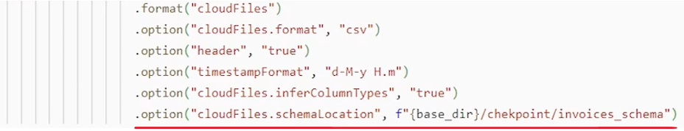

We know that we are reading data from CSV files, and auto loader is configured to infer column types, right? But we know sometimes infer schema is not very accurate. in the earlier lectures we saw that infer schema on the same data set, on the same sample files inferred a few columns as int, but we wanted it to be a string. So auto loader also comes with options to give schema hints so that the automatic infer schema feature. will identify some schema, but, we are giving a hint so that the auto loader can apply those hints. So let's add those hints and it will make more sense, then so option and then CloudFiles.SchemaHints. And then we can give schema hints as a comma separated schema hints, for different fields. So let me copy paste some fields here. This is how it is. So what I want. I know I'll be getting invoice number, in my ingestion files, and I am afraid that automatic schema inference will infer invoice numbers as int. Right. But I don't want invoice number to be int, I want it to be a string. Similarly, customer id, I am afraid that customer id might be inferred as int or long, but I want to give an hint that. Consider this to be a string. Right. So that's how we can fix, some potential problems in automatic schema inference for cloud files or auto loader. That's an additional capability available with the auto loader.

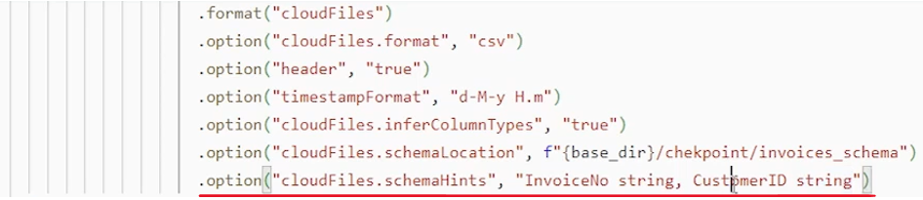

So that's pretty much all I've configured it. enough. so now let's load, and for loading I need to specify the cloud location. And that is in my base directory invoices directory. So that's all for Read Stream. So what we did, let's quickly revise.

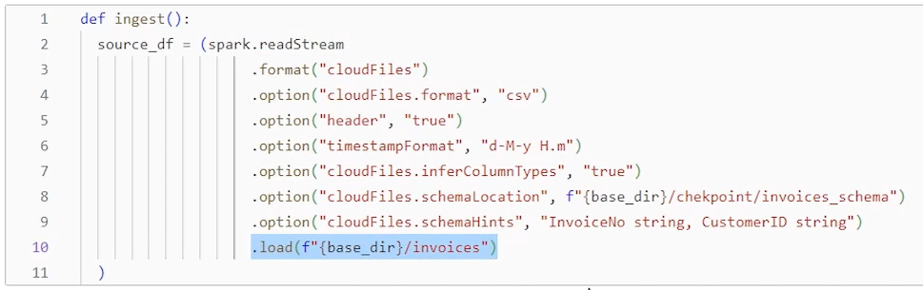

I am using Spark structured streaming API, spark dot read stream to read data from this location. But for reading data from the cloud files or from the cloud location, I want to use auto loader and how to configure auto loader. Simple. Use the format as cloud files. That's all done now. Read stream will use auto loader as a connector for reading data from the cloud location and behind the scene. Auto loader APIs will trigger. They will do the reading work for you and implement all the necessary, optimizations that they have. but we also need to specify the format for the data file so that we can configure using, cloud files format. And I told that it is CSV. Once we configure CSV, then we also have an option to use CSV options, CSV configurations. So I use two CSV configurations. For example, if you are ingesting parquet data or you are ingesting Json data, you can use Json configurations. here you will tell Json, and here you can use any Json configurations if you want. And after all that, we can also configure auto loader to infer column types, from the data file. So we setting that configuration to. Yes. And we know auto loader requires one location kind of checkpoint location where it can keep schema information so that it can resolve the schema related problems across Microbatches. So we tell that schema location. And then we can also, specify some schema hints because we are going to automatically infer data types. to fix those automatic inference problems we can specify some hints schema hints. That's all. So now I have source data frame. What is next. The next step is to, maybe write this source data frame into a target delta table in my bronze layer. Right. So. Writing data frame remains as it is. Same, right? Writing a stream to your table remains as it is. So it's a typical code. We don't have to configure anything related to cloud files or autoloader or auto loader works at the time of read write. It's a tool for efficiently reading data from the cloud directory. So all the cloud files are autoloader. Configurations are applicable at the time of reading. Once we have the data frame, it's, same as writing any, streaming data frame. So I'll quickly paste some code here for writing the, streaming data frame and then close the parenthesis inside. So my function is over here.

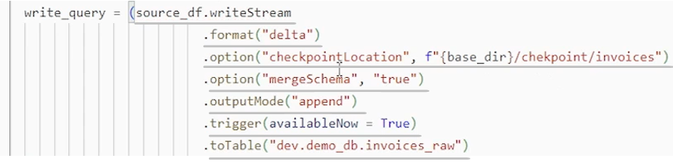

And I configured auto loader. I have written a function in jest function which will trigger the auto loader to ingest data from the cloud file. So let me call that function here at the end maybe in the same cell. And I can ingest data.

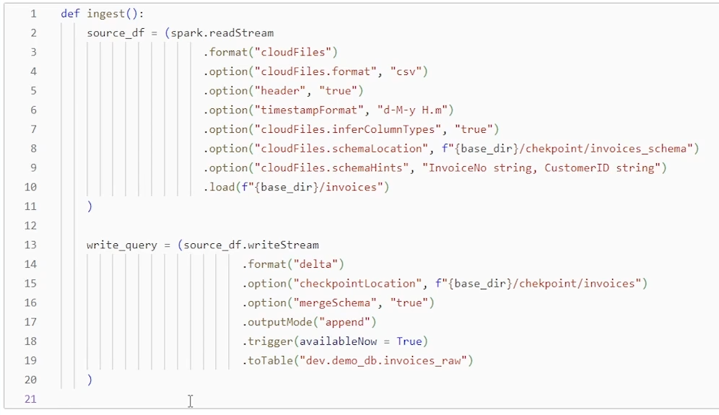

So all done let's try running it. And it should work I guess. So it finished and looks like it worked. one thing you should not forget because we are trying to implement automatic schema evolution and basically automatic schema evolution works at the time of writing. So this option is important in the right extreme right. So you must specify merge schema equal to true to enable automatic schema evolution. So that's done and data is ingested. Let's try looking at the table and see what we ingested. So we ingested all these files. data 793 records and all. Looks good, all fields, even invoice date looks like, inferred as a proper date type. maybe we can describe the table and see what is the data type of these columns.

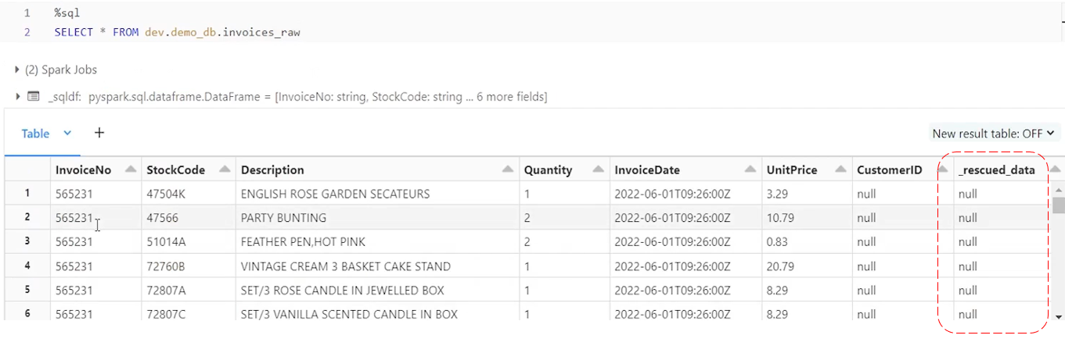

But I wanted you to notice this rescue data column. So underscore rescued data column. So this is an additional column added by auto loader automatically in your target table. And this column will be used to record any fields. From these fields in the table. If they cannot be translated or converted or read properly by the auto loader, according to your schema and schema cannot be evolved. So, all the problem fields will be recorded here. We will see an example in a minute. But notice that auto loader will add a underscore rescued data field in your table, possibly at the end. and use it to capture the. Invalid data or invalid fields. So let's describe the table next and see what is the schema. So let me describe it. So now we can see the schema invoice number is inferred as a string. without the schema hint it should have been inferred as int, but since I gave a schema hint, it is inferred as a string and invoice date is time is time. So that's correct. Unit price is double. So that's all we have. And rescued data is a string because the rescued data will be stored as a Json string. In that, column we will see an example. So, pretty much well, even schema inference, automatic schema inference works pretty much well with, auto loader due to schema hints. So now let's come to another scenario. the second scenario for auto loader.

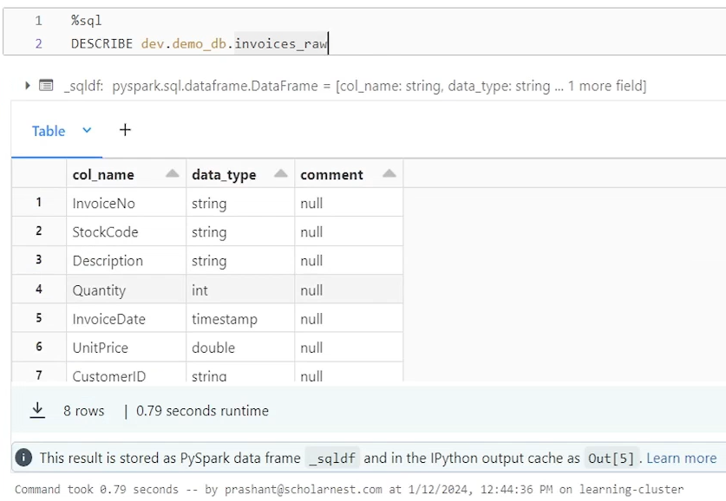

What if we receive some new data files with some additional columns. So to simulate that scenario I have prepared a data file which comes with some additional field, basically one additional field. So let me copy this into the landing zone directory. to simulate that some new data is ingested into the landing zone directory.

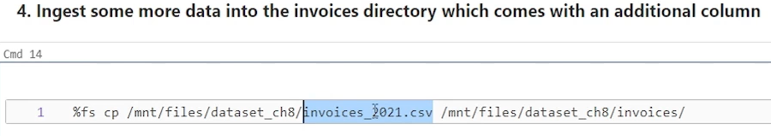

And then we will ingest the new file from auto loader. So now let's assume the new data has arrived. How do we ingest the new data file from the, cloud location? It's super simple. Run the next iteration of your, auto loader. So basically run the same function, execute the same function.

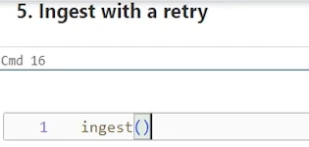

No code change is required at all. It will automatically identify new fields, manage the schema, and evolve the target table to include the new columns and load data for the new columns. into the target table. Everything works smooth without any code change. But how will we know that some new files or some new fields has arrived? Do we have a mechanism to know that we don't want our ingestion pipeline to fail, but we want to record somewhere that some new fields are now arrived and we are evolving a schema and we are incorporating or, consuming them. So for that auto loader comes with a feature. So the feature is that if new files has got some new fields, schema evolution is required, auto loader will fail. So let me run this. It looks funny. That auto loader will fail even after configuring it for automatic schema evolution. but let's see. So auto loader failed.

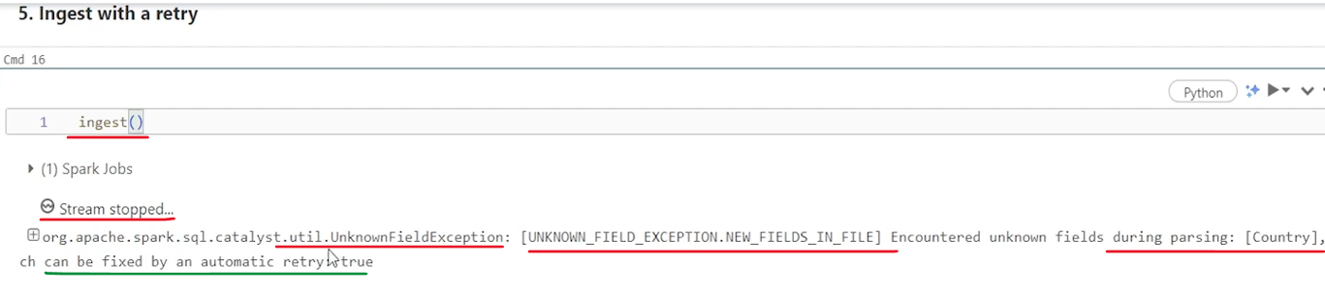

The ingest method failed. Failed with Exception, unknown field exception, and encountered unknown fields during parsing. Field name is country, so basically it fails, giving you an error. That schema need to be evolved, right? We identified some new fields and it wants you to retry. And in retry it will successfully complete. So the idea is when you build your code for auto loader ingestion, you will write these kind of function. And then in your pipeline you can implement retry. And these logs or these errors will be recorded as a notification for you. Or you can handle exception and create a better, alert or notification. the basically idea is auto loader will fail once, if there is any schema evolution detected. And then if you retry it again it will succeed. So let me retry it. I'm just running it again. And this time it will succeed. And which is good, which is a kind of very good feature of auto loader which gives us an opportunity to know, okay, we have got something new. We are evolving this schema. That's fine.

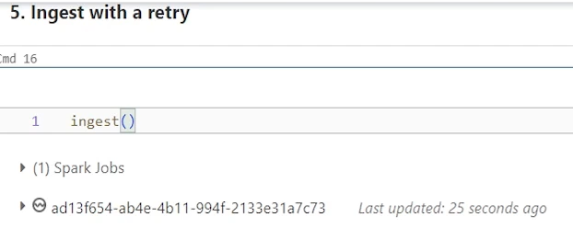

Don't stop, just retry and finish it. but. The error or schema evolution is recorded somewhere, right? So you can, go and look at that, log or those details. So it finished. And since it is finished, we should have little more records. Earlier, when we checked, we ingested 793 records. Now, let's check the data in the table. Let's see what we have got. So 1047 records. So we ingested some new data there. And let's look at the fields. So now I can see one extra country column added at the end. We have values here for the new records. It came after the underscore rescued data. But that is fine. that's how schema evolution will keep on adding new fields. towards the end. if you want you can investigate the schema using describe command and you will see that okay. Country column is added. It's a string. And that's what we wanted. So pretty much well, that's all about the, second scenario where we receive new data or new fields and we want to evolve the schema. And we learned how auto loader evolves the schema. It will fail once you retry it, and it will successfully evolve the schema and, ingest the data.

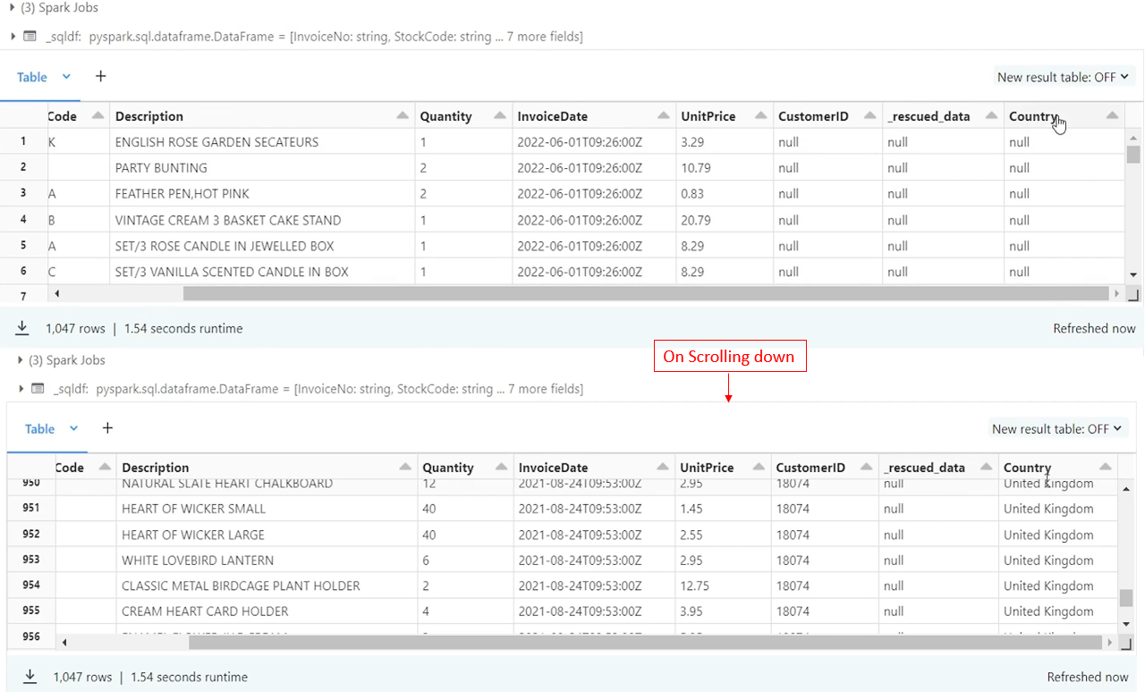

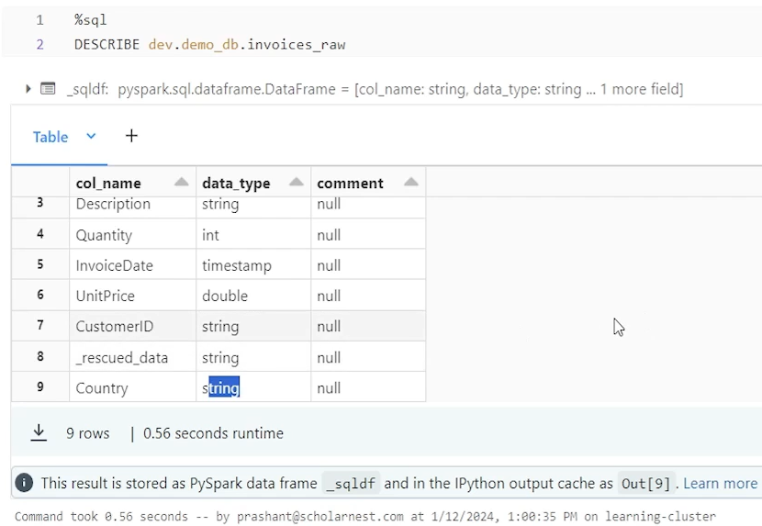

The third scenario, we want to understand how auto loader handles the rescued data or faulty data, which cannot be, parsed correctly or cannot be loaded into the target schema. So for, simulating that scenario, I have prepared one more file here, invoices 2022 dot CSV. So let's copy that file into the landing zone. to simulate that, we ingested a new data set, as new file. And there is one record which is faulty, which is not correct, something is incorrect in that record.

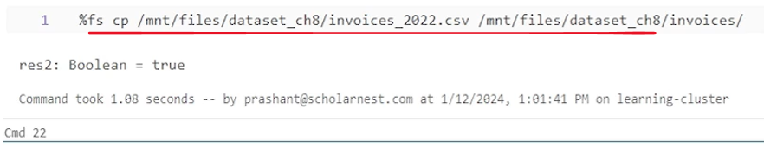

And we will see how auto loader helps in rescuing the faulty data. So let's run the auto loader. Once again it's simple. No code change is required. Just call the function. And since the schema evolution is not needed for this field, this file, it won't go for a retry. It will successfully finish in one go itself. So that's done.

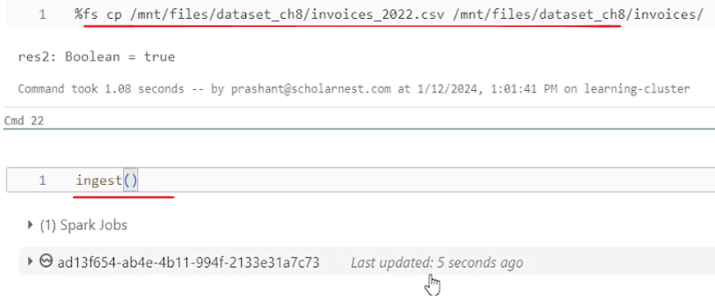

Now let's try to look at the data. I'm doing select star from this table where underscore rescued data is not null. So I purposefully created one error record in this, data set in this file to see how auto loader gives us the rescued data. So let's try to see what we have. We should have one rescue record. So underscore rescued is not null for this basically invoice number. This comes with incorrect invoice date. So basically spark structured streaming could not parse the date field of this record invoice date field. It could not parse it to timestamp. So since it could not successfully parse it to a valid timestamp, a spark streaming API will make it null and auto loader will capture the rescued data details here. So what is this?

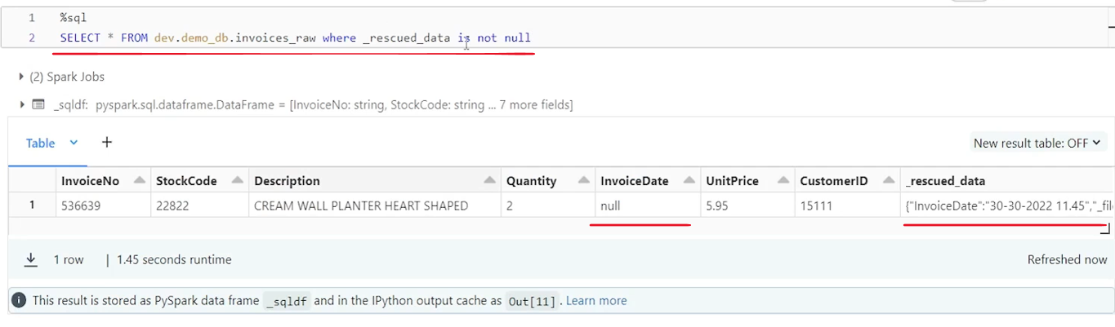

Let's look at it. It comes with enough detail, right. It is it is a Json string. Right. And it is clearly telling me that invoice date field, the ingested value is this, 30-30-2022. So this is definitely incorrect date. Right. 30-30 cannot be parsed correctly. We don't know.

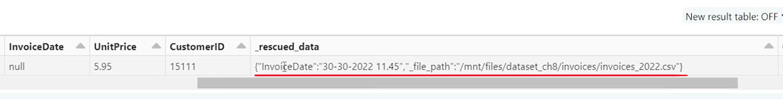

This should be DD. This should be MM. But there is no month for 30. So this is definitely incorrect data. So it captured the incorrect value. And the column value becomes null. And we have details here. What was the incoming value. And not only that we also know that in which file this incorrect record has arrived. So that's enough detail for us, with about the invalid data or invalid column, you can work with that later, from this file, if this can be fixed, we can fix, this value and update here so you can correct the data or maybe based on the rescue data, if it cannot be fixed, you can take a decision whether you want to keep this record, in the next layer or you want to filter it out as an incorrect record.

That's all about the autoloader. hope you learn how autoloader works, how to use it, and how to configure automatic schema evolution with, auto loader. one tricky thing is that if schema is evolving, auto loader will fail once you retry it and it will succeed. And we also learned how it captures the rescued data.

## Delta Live Tables





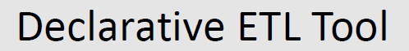

|  |  |
| --- | --- |
|  |  |

I'll give you an introduction to Databricks Delta Live Table or popularly known as Databricks Delta Pipelines. Let's start with a very simple question. What is Databricks Delta live table or DLT. So in simple terms DLT is a framework for building data processing pipelines. And it is a declarative ETL tool. We use this framework in two steps. So basically your pipeline development or DLT pipeline development happens in two parts. The first part is we write declarative pipeline code since it is a declarative ETL tool. So we write declarative pipeline code. And then second part of it is create a DLT pipeline using Databricks Workflow UI. So for using DLT we have two steps. And DLT in general is a declarative ETL tool. But what is declarative ETL tool.

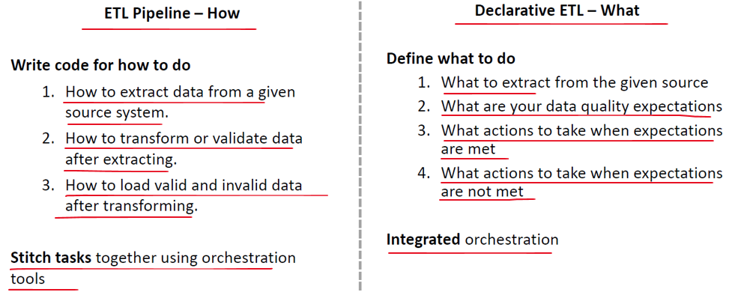

So let's try to understand what is declarative ETL tool. I am assuming that you already know what is ETL or traditional ETL. So in ETL we do three things extract, transform and load the data. We work with the data with three steps extract, transform and load. But in a traditional ETL pipeline we explain or write code for how to do things. So first thing we do how to extract data from a given source system. And that's E of the ETL tool. Then we next step explain how to transform or validate data after extracting. And that's your T in the ETL transform. So we write code for transforming and data validation etc..

Finally how to load valid and invalid data after transforming. And that's your load part or L in the ETL. So basically in a traditional ETL we define how to extract data, how to transform and validate data, and then finally how to load the transformed or validated data into a target, table and all. Once all this is defined, we stitch all these three parts together using an orchestration tool, um, such as Apache Airflow. Or maybe if you are in Azure Cloud, you might want to do it using Azure Data Factory. But what is declarative ETL tool? Declarative ETL tool is a new idea where instead of defining how to do, we define what to do. We still write code, but we write code for defining what to do.

<https://www.databricks.com/product/delta-live-tables>

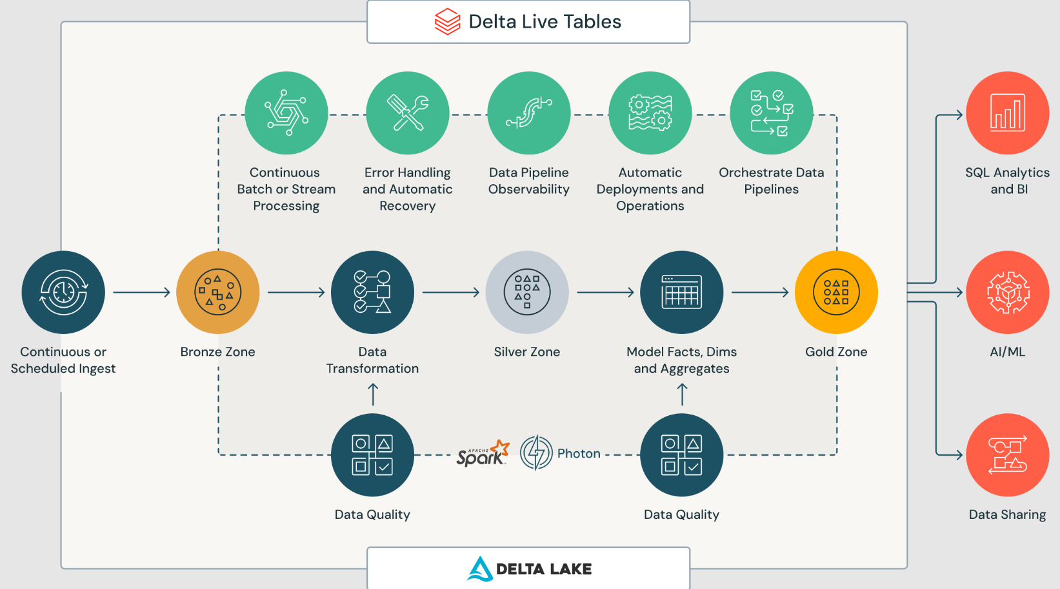

So in a declarative ETL tool, instead of defining how to extract data from a given source, we define what to extract data from a given source, and after extracting, we define what are your data quality expectations. So instead of defining how to validate data, we simply tell what are our data quality expectations, what we expect with the good quality data and what is a bad quality data. And once that expectations are evaluated, we define what actions to take when expectations are met means we have a good quality data. Similarly, what actions to take when expectations are not met? So what do we do with the poor quality or bad quality data? That's how declarative ETL works. And in a typical case, a declarative ETL comes with an integrated orchestration. So in Databricks, DLT is a declarative ETL and it comes with an integrated orchestration capability. And that's why when I said we implement DLT pipelines in two parts, the first part is write declarative pipeline code. And then second part is create a DLT pipeline using Databricks workflow. And this DLT pipeline is the orchestration that I mentioned here, which is integrated with your, DLT code.

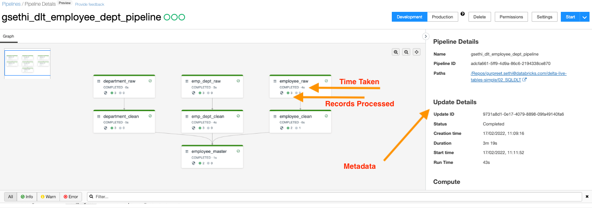

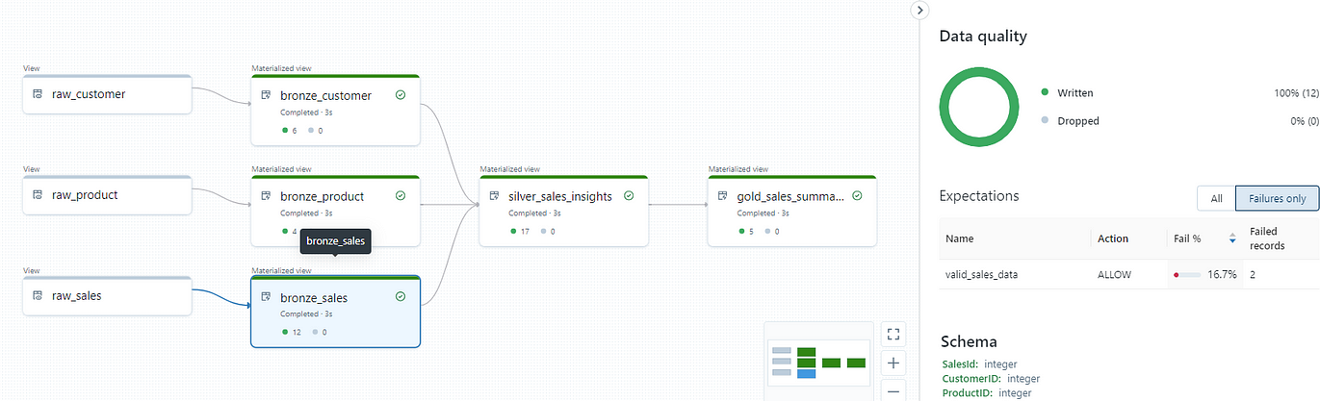

|  |  |
| --- | --- |
| So that's what the DLT pipeline is at very high level. DLT pipeline in Databricks allows us to define what to do. And along with that, it also offers a lot of other features, inbuilt capabilities like it can give you a dashboard or a UI to see your data lineage or visualize your entire pipeline. Like this  It gives you a nice presentation of your, pipeline. And it also gives you a report about the data quality. What is your data quality? What percent of data is high quality? What percent of data? Is poor quality. All that details it gives and also it gives you. Capability for monitoring your pipeline error handling and a lot of other things. |  |

So that's what the Databricks DLP is popularly known as DLP. But full form is Delta Live table. And that's all for this lecture. To understand DLP in a best possible way, we will have to understand some scenarios and start implementing it. Right. So that's what we are going to do.

### Understand DLT Use Case Scenario

Lets see scenario in Lake House project and understand how we can implement it using Delta live tables in Databricks platform.

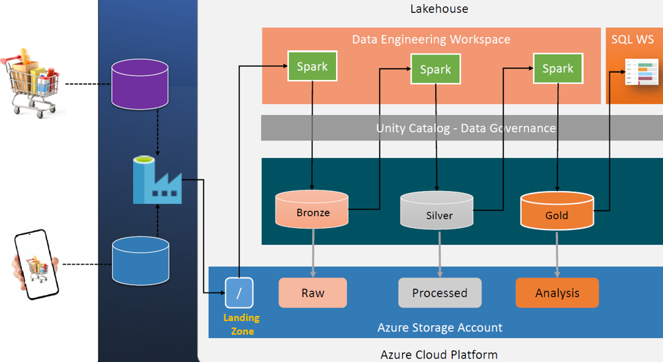

So let's start, so here is a diagram which represents a typical lake house project. What we do in Lake House project. We ingest data from our sources using some, suitable data ingestion tool, maybe bring it into a landing zone in our lake house platform, and then we start writing our lake house application from the landing zone onwards. First step would be to write some spark application or use auto loader to ingest data from the landing zone and build our bronze layer. Bronze layer is our raw data layer made up of, delta tables. And then we start building the rest of the application from the raw layer. So we again write some spark application, read data from the bronze layer, maybe implement some data quality checks, duplicate removal or data enrichment activity. And build our silver layer, tables. And from silver layer we again start a new application which reads from the silver layer and do some aggregations or prepare the final results for our consumers and save that into the gold layer. And then our consumers can read from the gold layer. They might want to build some dashboard or use it for machine learning or whatever purpose. So that's what we do, in a typical case in a lake house project.

And for doing all that, we write spark applications here for maybe three pieces of a spark application. And these spark applications define how to do things right. This spark application defines how to read data from landing zone and how to write it into the bronze layer. Similarly, this application defines how to read data from bronze layer, how to implement data quality checks, how to remove duplicates, how to build your dimension tables, or how to build your fact tables and prepare your data set for the silver layer.

And similarly, the last layer will define how to aggregate or how to summarize data, or how to prepare data for our consumers and save it in the gold layer. That's what we do. but Databricks offers us a declarative ETL tool known as DLT or Delta live tables. And Delta live tables allow us to do the entire journey starting from here till here. This entire journey using a declarative code and inbuilt, DLT pipeline. So to understand that, let's narrow down a scenario and, create a specific scenario which we can work out and along the way we will learn how to do it using declarative ETL tool DLT in Databricks. So to give you an idea, and learn DLT, I have prepared a specific scenario.

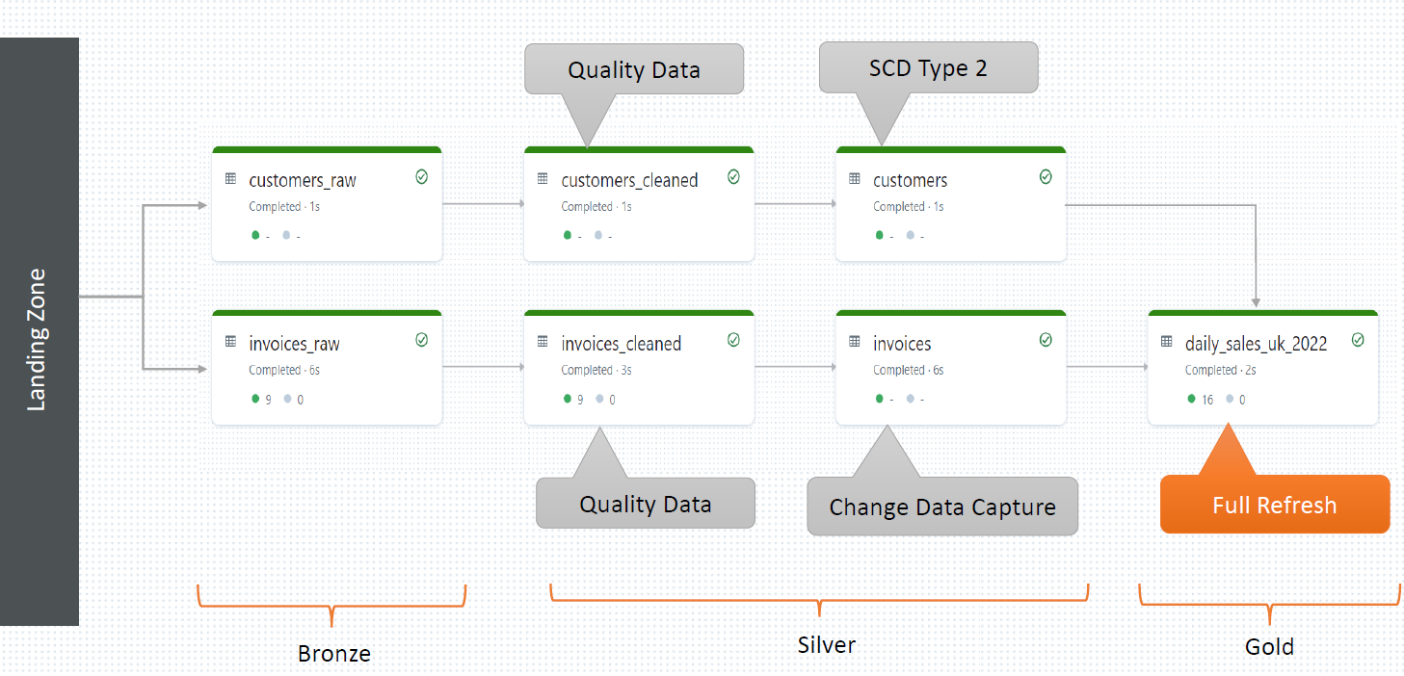

And this goes through the entire three layers of medallion architecture. So we are assuming that we have a landing zone here where we are ingesting data of using our data ingestion tool. And data is coming and sitting into the landing zone. And what we want to do, we want to work out with two data sets. One is your customer data and another one is your invoices data. Customer is a master information. So it's kind of will result into a dimension table invoices, transaction information. So it will result into a kind of fact table. So we want to, cover up one dimension table and one fact table. So let's work with the customer data set first. So customer data set comes into the landing zone. We want to build a pipeline which reads data from the landing zone and fills into customers_raw table. Customers_raw table is our bronze layer table. It is supposed to capture raw data as it arrives, so no transformation needed. Read data from the landing zone and fill it into customers_raw delta table. We can use auto loader to read data from the landing zone. Auto loader is more efficient, so we plan to use auto loader, but we want to do it using DLT pipeline. So we will learn how to use auto loader in a DLT pipeline to read data from landing zone and fill our bronze layer table.

Once data is in the bronze layer table, we will move forward. Read data from the customers rod table from the bronze layer table and apply some data quality checks and create our customer's clean data, which will have only high quality data filtering out the poor quality data. And this is an intermediate table right. So this table may contain duplicate records. It is also possible that you received a customer information today and again tomorrow you are receiving same customer information once again. Maybe customer information is updated or customer information is modified. So you might receive, another record for the same customer. So customer clean table is not supposed to do the duplicate removal. It's an intermediate table, so it will simply capture the duplicate records. But since this customer clean table may contain some duplicate records, we want to build a final customer dimension table, eliminating the duplicates.

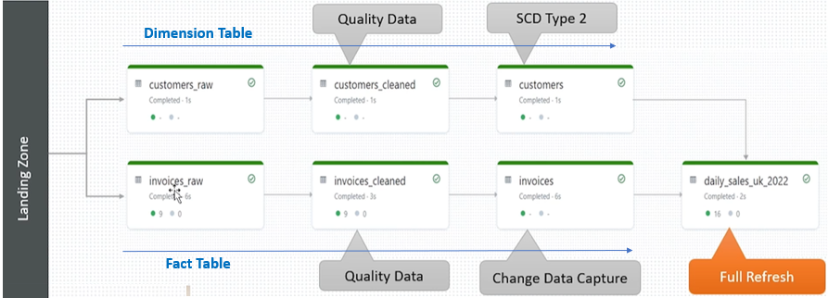

And since it's a dimension table, how do we implement, duplicate removal in dimension table? In a data warehousing world, we can implement you something called SCD type 2. In SCD type 2, when we receive a new information about, the customer, we close the previous record of the customer with the closing date, and we create one new record for the customer, with new information, with a starting date. So that's what, SCD type 2 implements. That's what we want to implement here. But we want to do it using DLT pipeline. So that's about the dimension table.

Similarly for this fact table we we consume new data from the landing zone as the invoices come in the landing zone, we want to consume it in near real time and build our invoices, raw table and from invoices_raw table. we want to implement some data quality checks and create a invoices clean table, which is a high data quality table. That's an intermediate table. So invoices, may have a duplicate records. Why? Simple. You received one invoice yesterday or maybe even today, 10 a.m.. But, 11 a.m. that invoice is updated. So you might receive an update for the same invoice, which will create a duplicate record. Duplicate invoice one is the original, another one is the updated information. But this is our intermediate table. So we want to keep the duplicates here, without worrying that duplicate. All we want to do is to filter out the poor quality records and keep only high quality records. Even if it is duplicate, that is fine, but in the next step we want to eliminate the duplicates and create our fact table. So fact table should contain only the latest information about the transaction. And that's kind of implementing CDC or change data capture algorithm right. So basically why you have duplicates here. Because you receive one invoice and then you received update about that same invoice. And that's how this change data capture or CDC works. So for the final fact table we want to implement the CDC logic, using merge statement and maintain our fact table with only the latest information. So that's all done up to silver layer. So we build our bronze layer, silver layer and all this we want to do using near real time or using streaming approach. Things up to here should be built using, incremental logic. So we don't want to re create or reprocess the entire data to build our dimension table or fact table. We want to only focus on the incremental data. So that is done up to here.



Finally we also want to calculate or build our daily sales report. So it's a daily sales report for country UK for year 2022. Right. So this one is our gold layer table. And we want to build this aggregate report using the full refresh technique. So I'm mixing in full refresh technique here. this up to here. Everything is your incremental data processing. And this one goes for the full refresh. So that's what we want to build as part of this learning exercise. So. That's all for this lecture. let's start building this. And along the way, we will learn the mechanics of using DLT pipeline.

### Setup DLT Scenario Dataset

Go to the workspace and the notebook

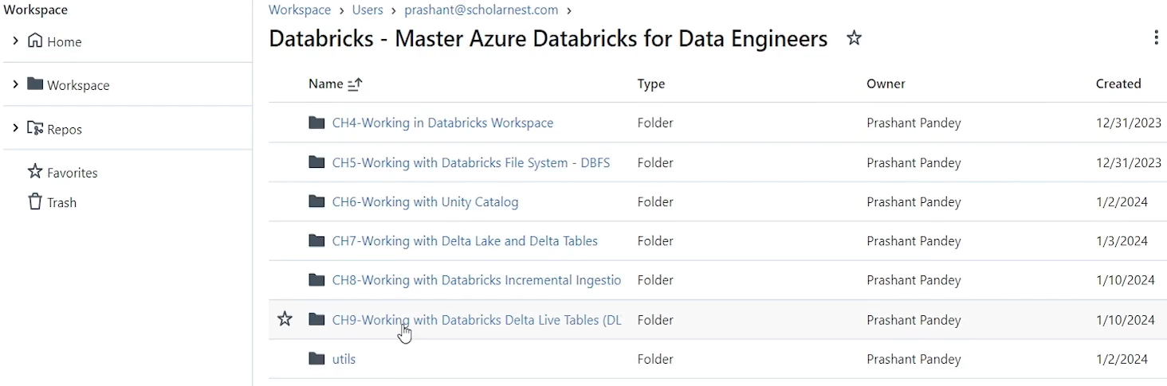

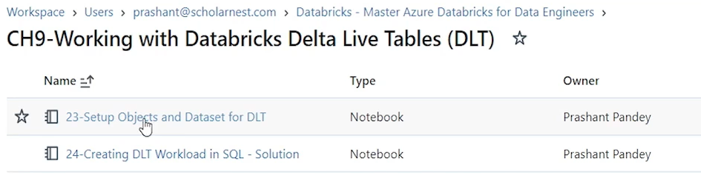

As usual lets do the cleanup and setup required

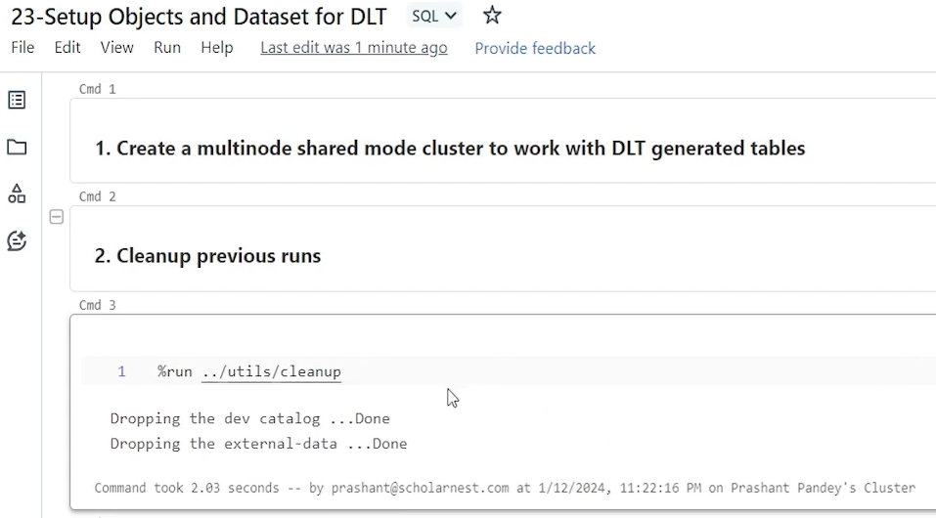

We don’t have a cluster, so lets create one for running this notebook

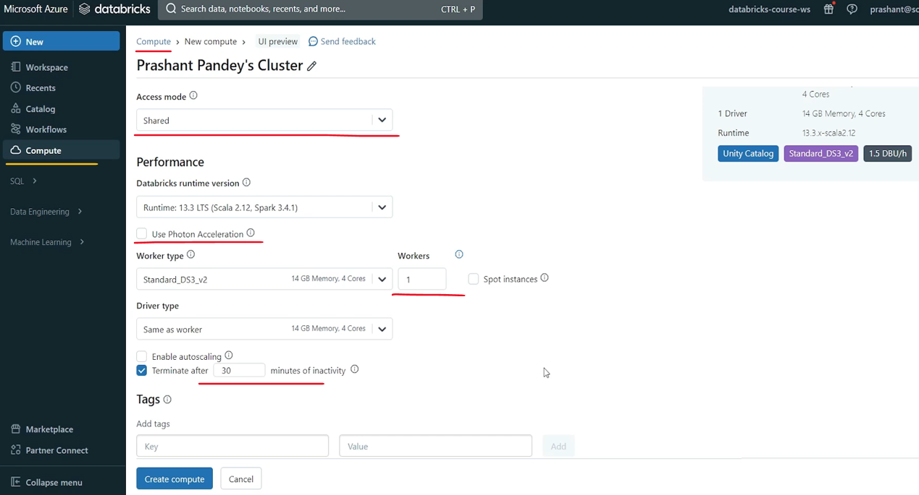

We have a multi node cluster running now

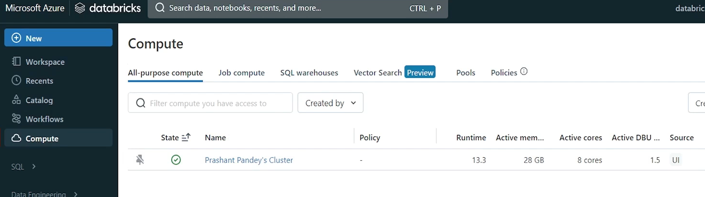

Let us attach this to the notebook

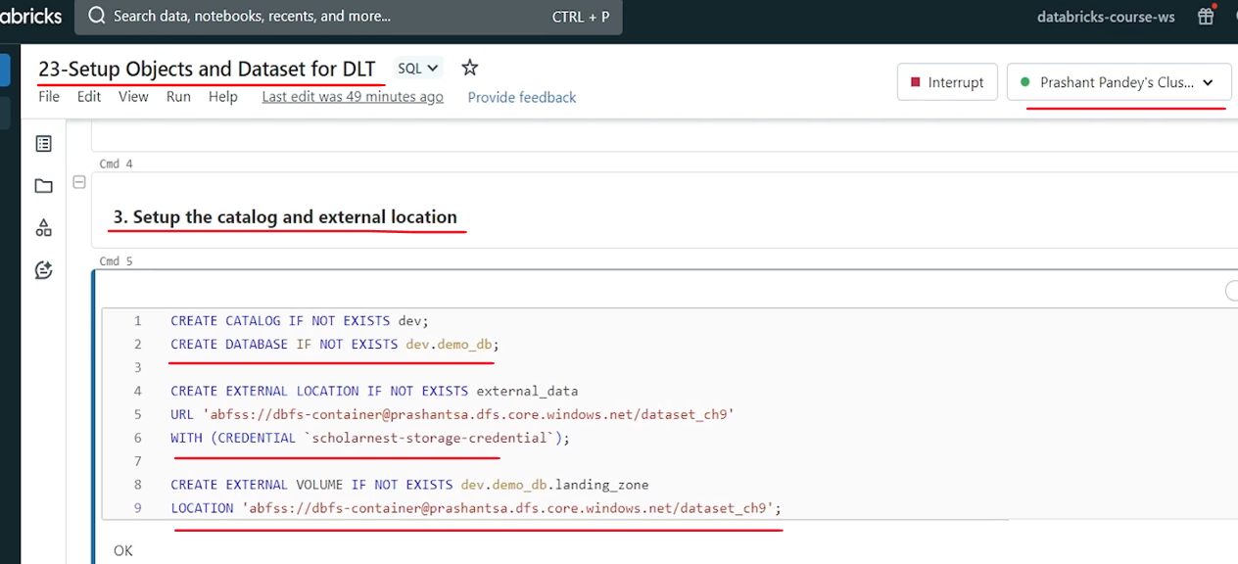

We will be creating our tables in the demo_db database under the catalog dev

We also created a external location, and then using that external location we are creating a landing zone volume – dev.demo_db.landing_zone. We will assume that our DLT pipeline we discussed can start consuming data from this landing zone.

In the landing zone directory we want to create a customers directory

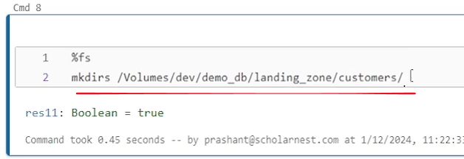

Similarly we also want to create a Invoices directory in the landing zone where we would get all the invoices

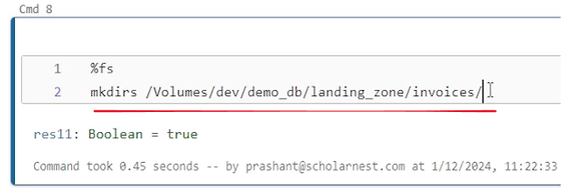

Before start ingestion into our DLT pipeline we want to ensure that there is some data already added to our landing zone directory. So, what we are doing here is – copying customers_1.csv, invoices_2021.csv and invoices_2022.csv into our landing zone directory.

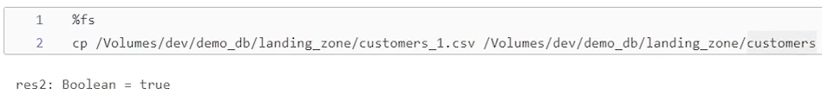

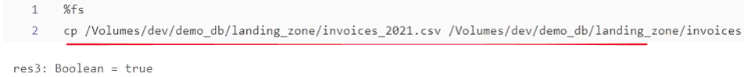

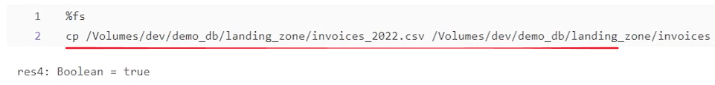

That is all the preparation that we were required to do before we run our DLT pipeline

|  |  |
| --- | --- |
| We are all set now to create and run the DLT pipeline  Customer, Invoices files in the Datasets are ready |  |

### Creating DLT Workload in SQL

We want to implement the scenario using DLT pipeline. So basically we will be creating our DLT pipeline Before we start writing code, let's look at the scenario. the first step in this scenario is to ingest customers_raw data and invoices_raw data into these two tables from the landing zone. That's what we want to achieve. And then we will talk about what is next. So let's do these two things as the first step.

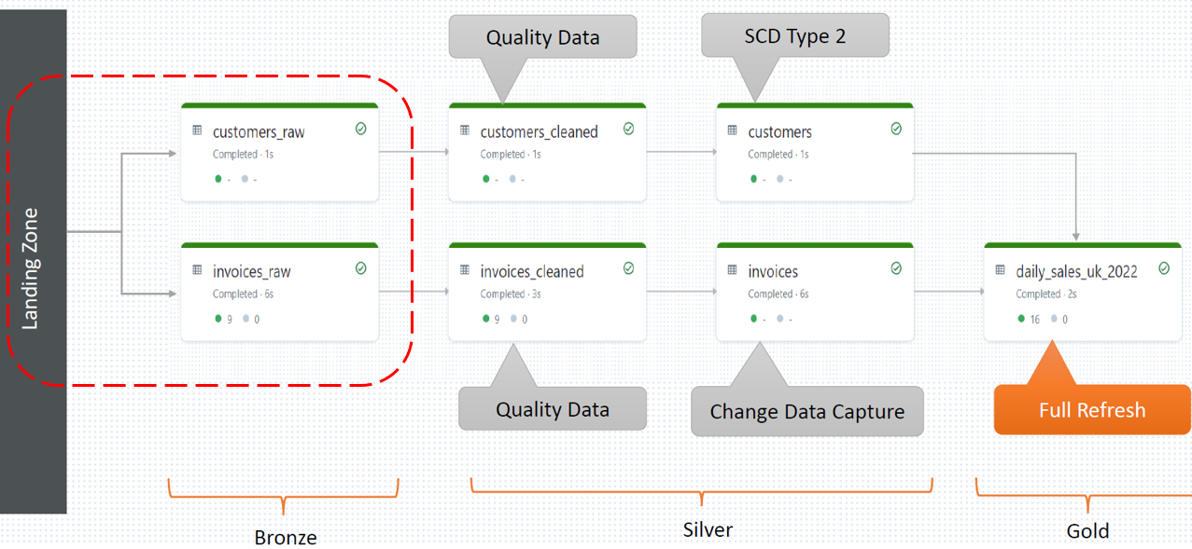

We want to ingest data from the landing zone into the customer's raw and similarly invoices into the invoices_raw. And we want to do it using auto loader. So we will use auto loader in the DLT to ingest data from the landing zone. So let's start. So I am in my Databricks workspace. let me go to my workspace in my home directory. I have set up one simple notebook. Basically it's empty. And we will be writing our DLT code, in this notebook.

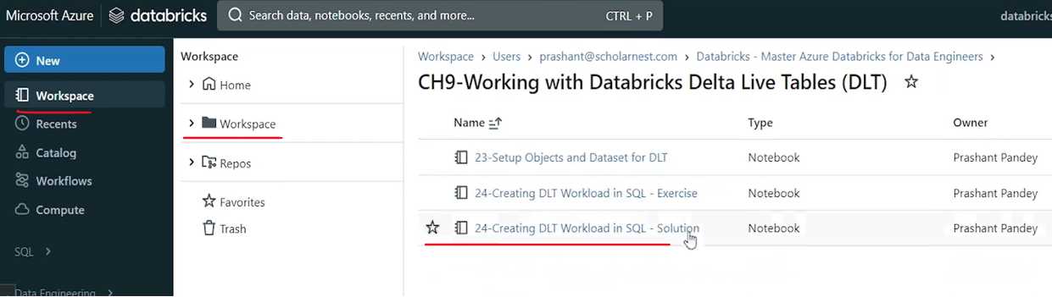

So the first step is to create your bronze layer table ingesting from the landing zone. And what do we want to create in the first we want to create our customers_raw table. So but we haven't created any customers_raw table. The table does not exist. So I want DLT pipeline or the DLT code itself to create the customers_raw table and then load data into the table. So two things we need to define here, create customers_raw table. And then second part is to load data into the table. So how to do it using DLT. DLT code can be written using a Spark SQL like syntax and also can be done using Python. So in this lecture we will learn how to do it using Spark SQL like syntax, Python we will learn later. So first step is to create a table for customers_raw. So we start with create or refresh. That's the difference. Normally in Create table DDL we say create or replace or simply create table if not exist. But here we will say create or refresh. So if table does not exist, DLT should create a new table. If table already exists, it should refresh the same table with the data from the source. So create or refresh. And then what do we want to create or refresh. We want to create or refresh our table and then give a table name. So let's say table name is customers_raw. So create or refresh table customers_raw. But we want DLT to create a table and fill that using incremental approach. We want to create a streaming table. So that's the trick herem we have to right. Create or refresh a streaming table customers_raw and that's the way we tell DLT to create or refresh a table which will be filled with a incremental data set. So so we create a streaming table.

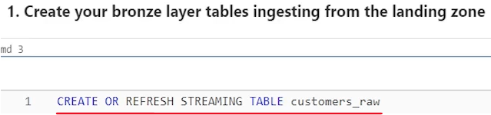

We want to tell DLT from where to get the data for this table. Right. So create the table this first part. But we also want to load the data into this table. So from where to get the data. And that can be told as simple as like select star. From. And maybe in the from clause you can tell get it from the cloud files right. So cloud files is our autoloader. So we have a cloud files function. And then in the cloud files function you can pass on the parameters to define your auto loader configuration and your landing zone directory. So the first parameter is your landing zone directory from where cloud files should start ingesting the data. So I'll simply paste the location here. So that's the cloud files location. we want to ingest data from the customers directory in the landing zone. And then next thing immediately we will have to tell okay, what is the file format. So maybe next parameter is CSV. So we tell what is the cloud file format. So data file is coming as CSV.

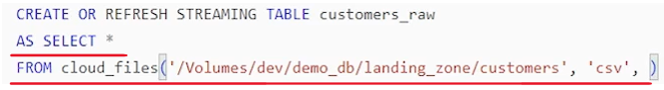

The next step is to specify any necessary cloud files configuration or auto loader configuration. So with DLP this cloud files function comes with some decent defaults. So it automatically configured with your schema evolution, automatic schema inference and checkpoint for storing the schema across the microbatches all that is taken care of by the DLP pipeline itself. And if required, we can give some additional configuration. So I want to give one configuration. So we learn how to give the additional cloud file configuration. So any additional, autoloader configurations can be provided as a map. And the map is nothing but a comma separated list of key value pairs. So you tell the configuration and give the value. And then if you want to give more configurations, put a comma, give the next configuration and then value and then comma next configuration and so on. So this is enough for our scenario. All I want to tell a cloud file to infer column types don't make everything a string. So try to infer column types. So that is pretty much all for ingesting data from a landing zone into customers_raw table.

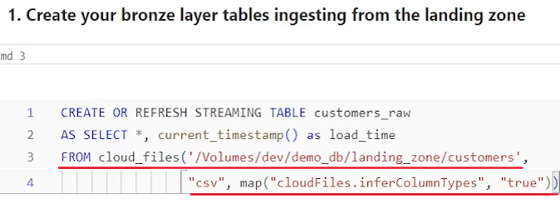

All will be taken care of by the DLT itself but I want to give one more field here. So we take everything from the, data file. But I also want to add a current time stamp, to my, this table, specifying at what time we ingested which record. So let me paste a code for that here. So I want an extra field called load time, which is current time stamp. So whatever time we ingest the record, it should be time stamped with the current time stamp. And we keep that as load time. So that's all. That's all the code I have for, ingesting data into customers_raw. can you write the same kind of, data ingestion code for invoices_raw. Right. It's very simple. Next step is to ingest invoices_raw. So let me paste the code for the invoices_raw I'm not going to type it again. Here it is simple. Create or refresh streaming table invoices_raw as select star take all the fields plus current time stamp as load time from where to get the data from cloud files. This is the location data file is coming as CSV, and we want cloud files or auto loader to infer column types. So that's all my bronze layer ingestion is done.

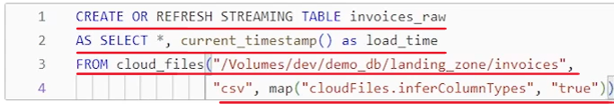

What is the next step in our requirement. So let me go back to the slide and see what is the next requirement. Okay so here we are.

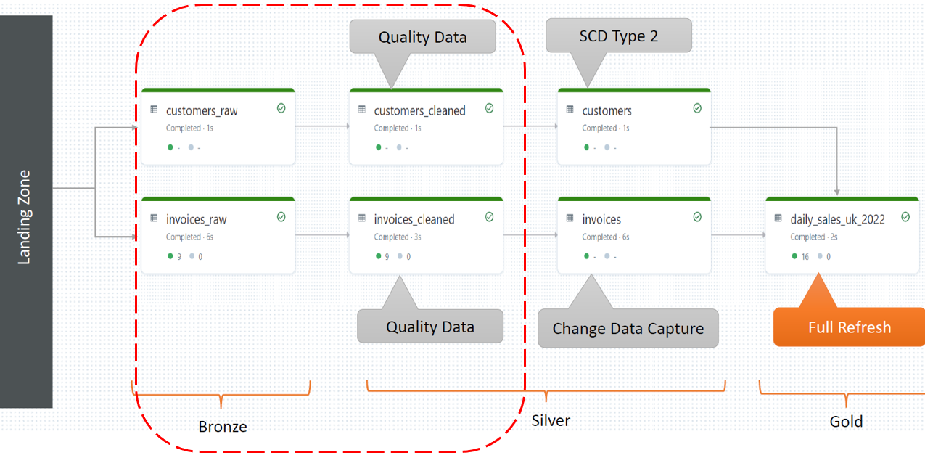

So next step is to read data from customers_raw and apply some data quality checks. to filter out the poor quality records and fill data into customers cleaned table. So we want to create one more table, table name is customers_cleaned and fill data from customers_raw into the customers_cleaned filtering out some poor quality records. So how to do that in DLT. That's the next step. So let's try learn that. So I'm back on my same DLT pipeline notebook and next step is to create your silver layer tables reading incremental data from bronze layer. So I'll write code for that here. how to write DLT code. There are always two parts of DLT code. You create a table and then fill the data into the table. Right. So we want to create a new table. And table name is customers_cleaned. I hope you already learned how to create tables. So in DLT. So I'll simply paste that line here. Here it is. Create or refresh a streaming table. Customers clean the entire silver layer we want to create using incremental data processing approach. Right. So all the tables in the silver layer are going to be streaming table. And this is how DLT knows that this table should be created using incremental data processing. So customers_cleaned will become an incremental table or simply called streaming table. but we also want to implement some data quality checks. Right.

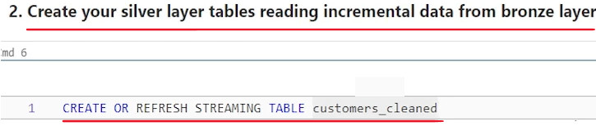

So in DLT, in the declarative ETL, data quality checks are performed through expectations. What is an expectation? It is simply a constraint. Like in traditional relational databases we implement constraints, right. So we add constraints to this table. and those constraints in DLT are known as expectations simply called data quality expectations. So how do we define expectations for this table I maybe put a parenthesis here. And in the parentheses we will define the expectations. So let's define it. expectation is defined or the constraint is defined as. Constraint and then give a constraint name. Let's call it valid_customer constraint. And then we say, okay, we expect this constraint. What we define the condition. For example, I want customer ID to be non-null. So simply say customer ID is not null. Simple, right. So what we are doing we are telling we are defining a constraint. Constraint name is valid_customer. And we expect that customer ID is not null. So if customer ID is null, constraint is violated. If constraint customer id is not null constraint passed. but what do we want to do. after that, what do we want to do if constraint is passed or constraint failed. Right. So that we can define here on. Violation. What do we want to do? Let's say drop Row. That's all.

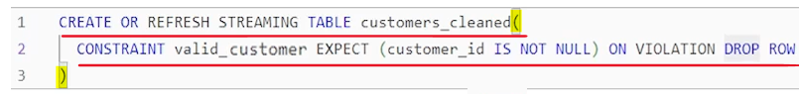

So what we did so far looks very simple. Create or refresh a streaming table. And this table has one constraint only valid_customer and this constraint. Expect this rule to pass. And if this rule is violated, drop the row. Leave that row. Do not insert that row into the customer's cleaned. That is all. We are done defining a table and we are also done defining a data quality expectation.

Now, we need to fill the data into this table. Right. So we need to specify the second part, how to fill the data. So that's as usual as like we did earlier as and then we do the select expression where to get the data. So as let's say select star or maybe you can type a specific column names, assuming that there are so many columns coming about the customer from the source, we don't want to bring all the columns. We are interested only in a specific column. So you can do that also. So let me paste uh select expression here. Simple. So I'm bringing CustomerID and renaming the column as customer_id. So I'm taking CustomerName and renaming that name as customer_name. So basically I'm also implementing a standardized version of the column names. And then load time. And from where this data will come from. And this data should come from the customers_raw table from my bronze layer table. So from, this table. But this table is a DLT table. It's a streaming table created by the DLT pipeline. I am not specifying any catalog name or database name here. so where do we find this table? In which schema or in which database? I can find this table? So tables that are created within the DLT pipeline by the DLT itself can be referred using a keyword called live. A live is like a intermediate or temporary, schema created by the DLT, where all these files, can be found or referred. So all these tables that we are creating within the DLT pipeline itself, can be referred using live.<table name>. So live is like a schema here. And since my source table, this table is a streaming table, I'll also wrap this, table name inside a stream. So I'll simply say stream. And that's all.

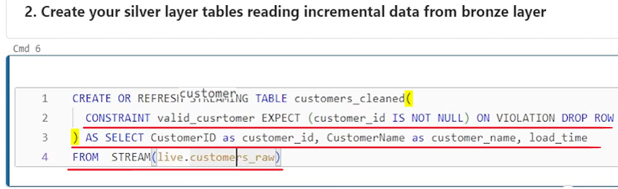

So that's how we refer DLT tables within the DLT pipeline. So customers_raw table is created within the DLT pipeline. So I can refer it using live customers_raw. And since it is a streaming data set it's an incremental table. So I have to specify it with a stream. To read it as a streaming table means I want to read it in incremental using incremental approach. I don't want to read the entire table, I just want to read the incremental data from this table. And that's why this stream is important. If you don't give that stream, keyword here, if you don't wrap it, then this code will try to read the entire table. But we don't want that. We want to read only the incremental data. And that's why I'm putting a stream here. And that is kind of all my customer cleansed or cleaned. table is defined in the DLT. Similarly you can define your invoices clean table also code is similar. I hope you can write that.

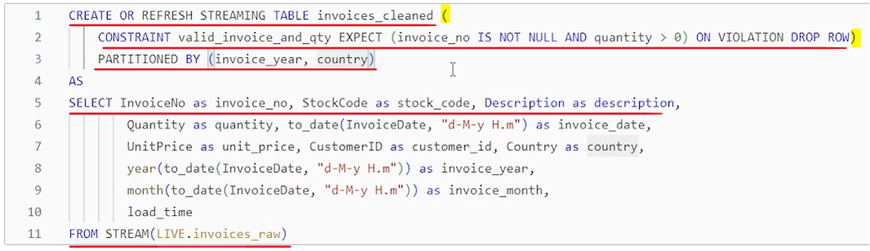

That's the code for invoices cleaned. So what I am doing create or refresh streaming table because this table also I want to build, as a streaming table using incremental data. Table name is invoice cleaned. And within this pair of parenthesis I am defining a constraint. So constraint is valid invoice and quantity. What is the rule that I expect it to pass? rule is simple. Invoice number is not null and quantity is greater than zero right. So both the conditions should pass on violation drop the row. So we drop this record. And if these two constraints failed. And that's how we check the data quality. but I also want this table to be partitioned so that flexibility is also there with the DLT. It's not like that. You can create table only. You can also create a partition table.

So I want this table to become partitioned on invoice year and country two columns. The reason is that this is my fact table. It's going to be large. fact table is assumed to consume and collect a lot of data. So it's advisable to keep this partition, so that rest of the queries, the aggregation queries can perform faster. So I am implementing partition.

Where is the data coming from this table? as select and simple I have a select expression. And this select expression gives me an opportunity to implement some kind of transformation. Also. So if I am simply doing simple transformations like invoice number renamed as invoice underscore number, these column is also renamed Right Quantity and invoice date. Maybe it is coming as string because while building my bronze layer here here I have not defined date time format and all that so that it can infer the date time columns correctly. So I am assuming that invoice raw will infer the date time column as string. So I want to fix that. So I know invoice date will be inferred as a string. So I want to fix that, fix that, convert it into a two date and rename the result as invoice date. Similarly unit price, customer ID country all that fine invoice date. Again I'm, adding two extra columns. So invoice year invoice month. So how to derive the value for invoice here, taking invoice date, converting into a proper date and then taking year part of the date of the invoice date and keeping it as invoice year and then invoice month. And finally I also take the load date or load timestamp from the bronze layer. And this is the column which I am using for, first level partitioning and country column for the second level partitioning and source for this is invoice is raw. it's created in the DLT pipeline itself. So I can refer invoices_raw using live dot invoices_raw. If I don't use live Dot, then maybe pipeline will try to find this table in my. Default database, right? but I know this is not created in the default database. It is created as part of the delta. Delta live table pipeline. So I can refer it using live schema. And I want. Don't want to read this table full. every time I refresh this, clean table, I don't want to read the entire table. I only want to read the incremental data. So that's why I am using a stream here. So read only incremental data. That's what this stream tells.

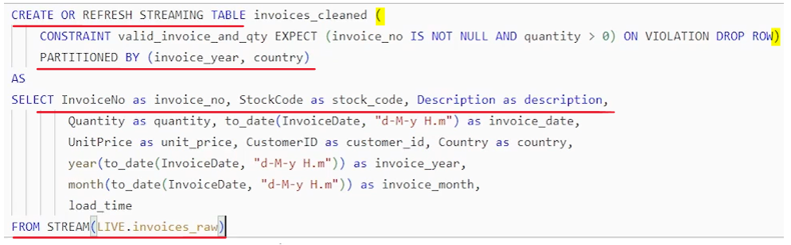

And that's all we are done with the, first intermediate table or high quality data table for, my silver layer. What is the next step? Let's go back to our. diagram and try to see what is the next step. So here is the slide. we prepared these two tables, right. customers_cleaned and invoices cleaned. Next step is to prepare the customers table and similarly invoices table. But these two are completely different, customers table should implement SCD type 2.

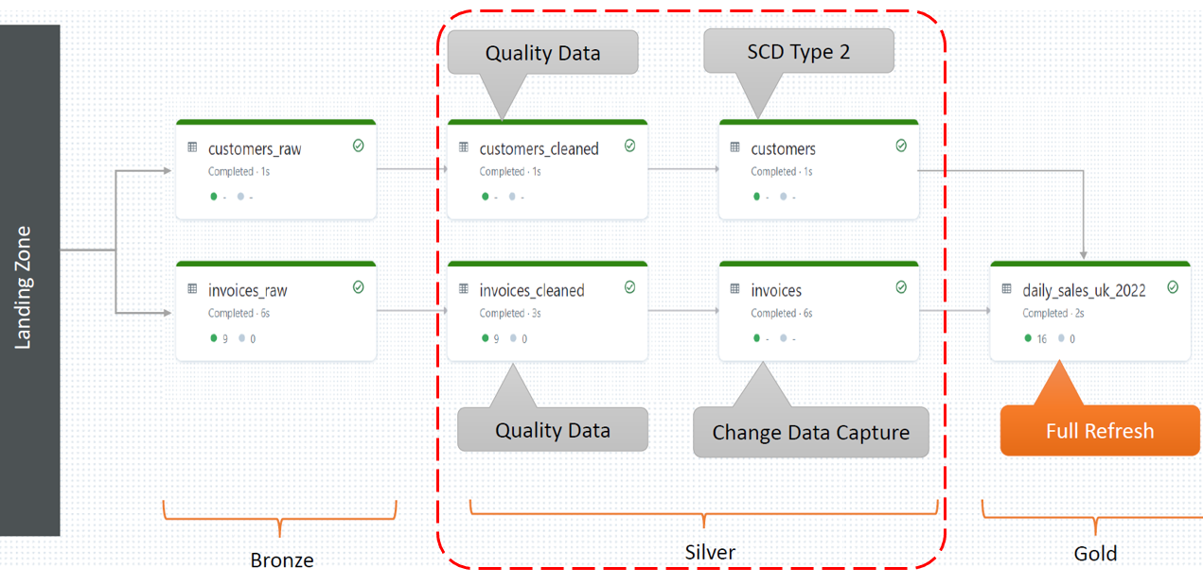

So when a updated customer information comes we want to implement SCD type 2 for the update. And you already know what is SCD type 2. What do we do in the SCD type 2. The old record will be closed and marked inactive with the timestamp. And then new updated information about the customer will also get inserted in the in the customers table and it will be time stamped marked as active. So it's like till 15th January. The old record was active and from 16th January the new updated information has arrived. So, customers information is active from 16th January onwards using the new record. So that's what we want to implement here, let's code this because this is completely new. we want to implement SCD type 2. Okay. So step three is to build your SCD type 2 dimensions using CDC from silver layer. So how do we do it? Again there are only two parts of every DLT statement. Part one is create the target table and then part two is fill the data into the target table. We specified two things.

So first part is create the target table. Target table name is customer. So how do we create the target table. Same statement. Let me paste it create or refresh streaming table customers. This table also I want to be an streaming table which will be filled only with the incremental data. it won't be refreshed again and again completely. So only incremental data will be processed. So create this. And then we put a semicolon here because we want to write a separate statement for how to fill what data to fill in this table.

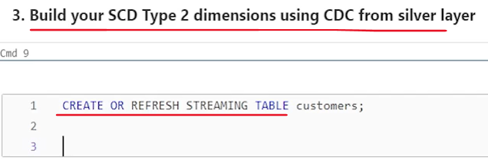

Now earlier we were writing it create or refresh table or streaming table invoices cleaned give any constraint if you want. And after that we, In continuation of this same statement, we give how to fill data using as and then build our select expression.

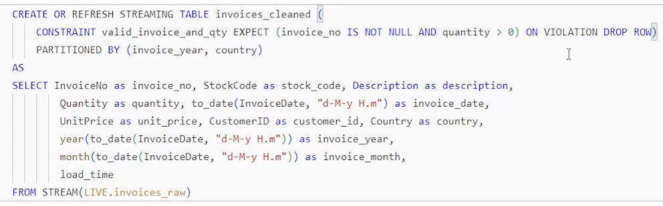

But here what we want to do we want to implement a CD type two, which behind the scene is done using merge statement or a complex logic. plus a merge statement because it is duplicate removal. And duplicate removal is done simply using the merge statement. Right? If record already exists, update that record, and if record does not exist, then insert that record. That's what the merge statement does. So in DLT, applying merge statement comes with a separate syntax, a different syntax. So let's try to learn what is the syntax for implementing the merge statement. And we will put up some configuration so that that merge statement is extended to implement SCD type 2. So let's try to learn that. So statement is as simple as apply changes into customers table. Right. But it is a live table. So live dot customers table. So apply changes into customers table. And then we tell, what is the source, so from and from is my customers_cleaned table. But I want to read only incremental data. So I'll put it in a stream function or wrap it inside the stream. And then it is, DLT created table. So I can refer that using live.customers_cleaned.

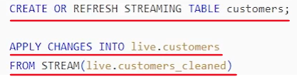

So apply changes into this target table from this is the source table. And what is next. You know merge statement. Merge statement. We define the join condition how to find the record already exist or not. Right. So to define the join condition we simply say okay keys and tell what is the unique key. It's a single column or a composite column. So whatever the unique key, is there in your, customers table that you have to tell here. So what could be the unique key? maybe customer ID? That is what we want, to be non-null always. So let's make customer ID as unique key. So key is a single column key, which is customer ID. So we are kind of writing merge statement, in a different syntax in, in a declarative syntax we are not telling how to merge. We are simply saying apply changes into the customers table from customers clean table using only incremental data and for merging match the records using customer ID and what is next?

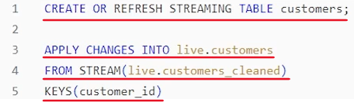

What to do next. Next is a very powerful feature of, DLT apply changes. We call it. Sequence by. Sequence by and in sequence by. I want to tell, one field, kind of load time. Right. So sequence by load time, what does it mean if we have received two updates for the same customer? Right. One is updated at maybe 10 a.m., another update at maybe 11 a.m.. So we will have two updates and target is one record. So which one of these two we should take for building our, SCD type 2 to dimension? Maybe you should first implement it using first record, then implement it using the second record. First record is 10 a.m. record. Second record is, 11 a.m. record. So all that makes your logic very complex. If you are coding for that, you will have to, implement a sorting and then implement it step by step for both, or ignore the first one and implement the second one. But DLT is a declarative tool. We simply tell, okay, if there are duplicate inputs for the same customer ID, sort them by load time and then implement the SCD type 2. And that's what the sequence by will do. So it's a magical, very powerful feature, of DLT.

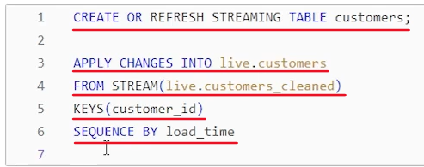

And what is the next we are done. but we need to tell that we want to implement SCD type 2 because DLT gives you options for implementing SCD type one. SCD type 2. CDC simple override the same record CDC multiple options. So we want to tell okay in this scenario for this customers table. This customers table we want to implement SCD type 2. So that can be told as stored. As a, c, d. Type two. Right. And put a semicolon. We have two statements in this single cell. This is the first statement. This is the second statement. So it is mandatory to use semicolons to separate these. And that's all we are done. Build your city type two dimension using your silver layer table which is your this clean table into your final dimension. Super simple. And we will run it and see how it implements. What is the result. But we are done.

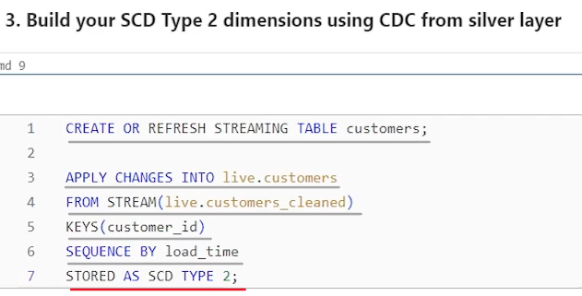

So we are done with the, customer dimension. What is the next step. Let's go back and look at our requirement diagram. So here it is. So we built, this and now next one is this invoices. So we want to build the invoices fact table. And in the fact table we don't want duplicates. We want one record for one invoice which should be the latest information. It is possible that invoices coming as update. Right. So it is possible that you got 9 a.m.. You got one invoice and 915 you got another update for the same invoice ID and that's possible, right? So how do we handle that simple. Merge the 915 record after the 9 a.m. record into the same table and overwrite the data or update the existing record. And that also can be done using merge statement. Merge means merge into the target table using the source records, and if record is matched, update that same record. If not, insert it. So how do we implement merge, simple merge which is not a CD type two, which is kind of change data capture. Right. So. how do we do that? Let's do that for invoices.

The next step is to merge into fact table using CDC from the silver layer. So how do we do that again two steps. Create the table. Create or refresh the table. And then step two is to provide the details how to fill data into that table. So let me copy paste the code for creating the table. That's simple. Here is the code. create or refresh. I want this also to be a streaming table, which should be filled using incremental data. table name is invoices. And I want this table to be partitioned by invoice year and country. So earlier also we tried to partition the invoices_cleaned table using invoice year and country. Same way. We also want to partition our fact table using invoice year and country. So I'm specifying that option. So table is defined.

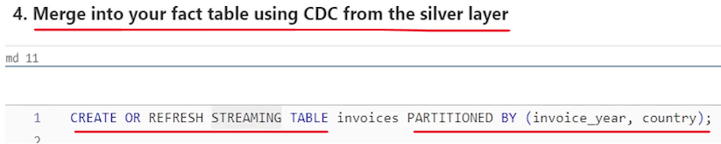

What is the next. The next step is to provide details how to fill data into this table. So let's do that. So in this case also we want to implement merge statement. It's not a single Select statement. So in DLT there are only two syntaxes. One is your select. Read data from source. Do some transformation as part of the select expression and write it into the target table. In our case, we are reading from one table, but you can do all kind of things. Like you can join two tables, you can do an aggregation. Whatever you want to do, it's you have the full flexibility of the SQL expression and build complex transformations. Other option is apply changes, which is a kind of merge statement. And with the merge statement or with the apply changes, you have multiple options. We used SCD type 2 here

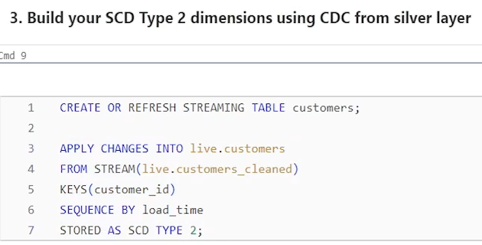

but this time we want to implement a simple merge statement. So syntax is same apply changes. So let's do apply. Changes into what is the target table? This is my invoices table. Same like earlier, but it is a live table. I can access it using live dot. And then we tell data where is data coming from? So from and from where data is coming. Data is coming from invoices cleaned. Right. And. I want to read only incremental data. So put a stream there and use live dot invoice stream. So data is coming from, invoices cleaned. And then once we have the data we have to tell what are the keys for matching. Right. So what is the key in the invoices. maybe let's go look at it. Maybe invoice number is a good key.

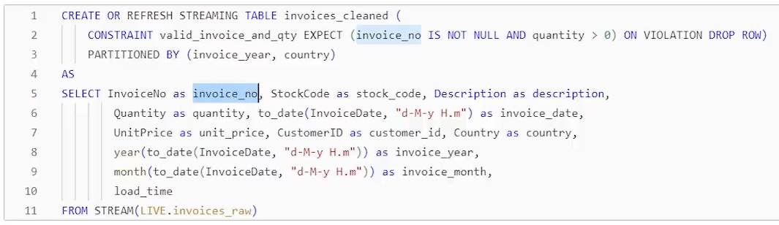

So we put invoice number here, but, let's think it about it a little carefully. invoice is coming with the invoice number. Looks like for each invoice, we will get multiple records, right. for each invoice, basically this is invoice line item. So if in one invoice, there are three items sold, we will get three records, one line item, one records, and second line item, second record, third line item, third record. And that's why we have a stock code and description quantity price. All those details are there. So basically invoice number is not a unique key. So I'll have to use some composite key. So I think using a stock code and invoice data is a composite unique key for my invoices record, based on my data set. So that's how you can use composite key for matching right. So that's pretty simple.

So we defined apply changes into this from this table. Match it using this. And it will automatically assume when not matched insert when matched update. That's what we want. merge statement to do. But we still have the sequencing problem, right? What if, two updates arrived for the same invoice? one update arrived at 9:15, another at 9:18. Do you want to implement 915 first and 918 second? Yes. If we implement 9:18 first and then 9:15 second, then we are overwriting the new information with the old information which will corrupt our data. So sequence is a very critical thing here. So whenever you are doing merge, even if you are manually implementing merge in your fact or in dimension, you should implement a sequencing logic there.

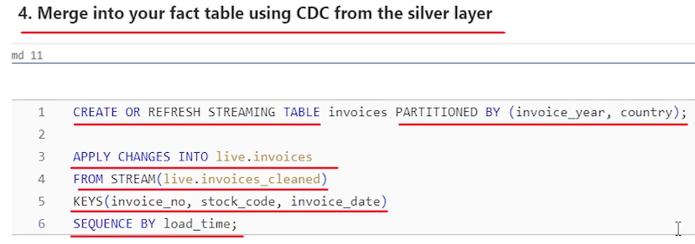

But, DLT gives us an easy way, to implement sequencing. So sequence by and what is the field here. You have to have some field which identifies the order in which the transaction happened. I am using load time here, but ideally, Your record itself should have a created time stamp, right? and you can use that for sequencing. but since my input data set doesn't come with the created time stamp, I purposefully created load time stamp. So at least I know what time I'm which record I'm loading first and which record I'm loading second. And then, I can do sequencing based on the load time, but in best case, your data should. Tell itself that what time this transaction happened and which transaction happened first and which transaction happened second. and that's all we are done with that. Put a semicolon and we are done with, implementing our fact table. That's all. So what is next? Let's go back to the diagram. So we kind of implemented all up to here. We implemented bronze layer. We implemented a silver layer. we haven't written more than 50 lines yet. The last step is to create this, gold layer table. And we want this table to, refresh itself, fully.

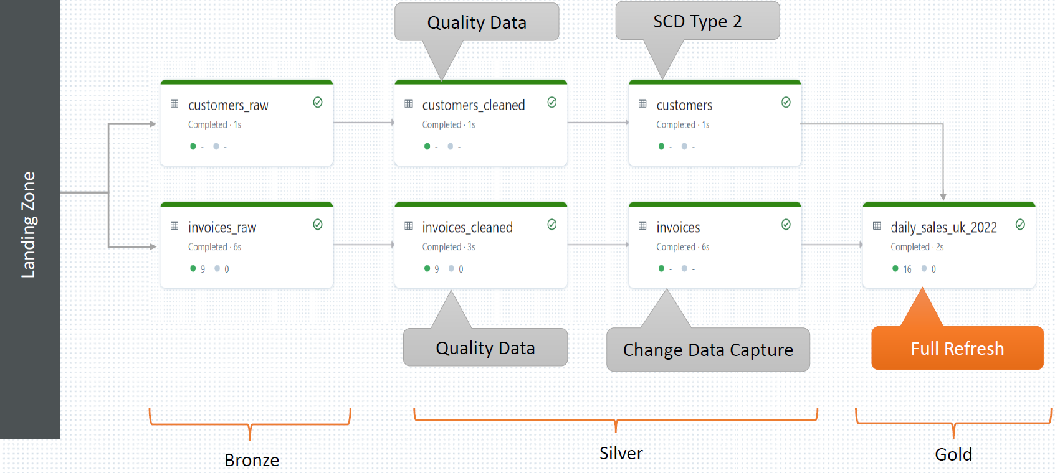

So full refresh means what you have two options. You can create a view. So view is always refreshed when you query that view. Right when you use that view. So but view has a disadvantage. every time you touch that view the query is fired and it will go and query the base tables once again. So views are, typically slow. What is the alternative approach. Think about the databases or data warehouses. We have materialized views right.

So materialized view is filled with the data. So it is refreshed when there is any change in the source table we refresh the materialized view and once it is refreshed, your customers or consumers can query the materialized view and it should perform fast. Because this is a reporting table which is small aggregated table and it should perform fast. So full refresh in DLT is done using implementing a materialized view for your table. So in this last step, what we want to do, we want to create a daily sales UK 2022 materialized view. So far we have been creating streaming tables which are incremental tables. Those are tables right? We load data into those tables and those are incremental tables. But this one we want to implement as a materialized view. So let's see how to do that.

You can also implement it using view but we prefer using Materialized view. So let's see how to do that. The last step is to materialize your gold layer summary using silver layer Fact. So how do we do that? Simple here also, all I have to tell - create or refresh a table and how to fill data for that table. So we'll give a SQL expression for that. So let's do create or refresh. what do we want to do? Earlier, we wanted to do an streaming table, which is an incremental table. This time we want to do a materialized view. So the keyword in DLT for creating a materialized view is live. So we want to create or refresh a live table. And table name should be. daily_sales_uk_2022. So simple.

We want to create or refresh live table and this live represents a materialized view. if you are want to build an incremental table, you will build streaming table. If you want to create a materialized view, which is fully refreshed every time there is a change in the source data set, you will create a live table. That's why the live means it is live. It always, refreshes and gives you the latest live state of your data. And once this is done, you can specify how to create that materialized view. So as and put up your aggregation query. That's all. So let me put up paste the aggregation query here. Here is the select statement.

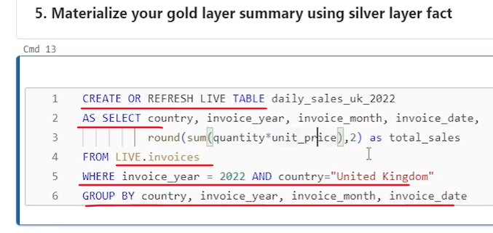

So what do we want to do. Select country invoice here. Investment invoice date and sum of quantity into price. Round it to two digits and rename it as Total sales. So basically we want to calculate total sales by country, invoice year, Invoice month and invoice date. And since it is only for UK and year 2022, I want to apply a filter where invoice year is equal to 2022 and country is United Kingdom. So that's all. and for creating this sum aggregate you have to group by so group by country, invoice year, invoice month and invoice date. That's all. One more important thing. we don't want to create this aggregate using incremental data only. I want to create aggregate reading the full record. So I'm reading, full invoices table. So I'm not using stream keyword here. So that's all we are done with the writing DLT code.

What is the Databricks DLT pipeline code. So we are done with the first part. If you recall your earlier lectures we talked about DLT can be implemented in two stages. First stage is to write your declarative ETL code. We are done with that first stage. Second stage is define your DLT pipeline, using the Databricks Workflow UI. So that's what we are going to do in the next lecture. Define your DLT pipeline so that it can be scheduled or executed on a regular basis, or can be scheduled to run as a continuous pipeline.

### Creating DLT Pipeline for your Workload

We learned to write declarative ETL code for our DLT pipeline. So we are done with the coding. we want to learn how to create a pipeline and schedule it to run, at a regular interval or as a continuous, workflow. So let's get started. So creating a DLT pipeline can be done from the workflow menu, you can come to workflows in the Databricks environment and come to the Delta Live table menu.

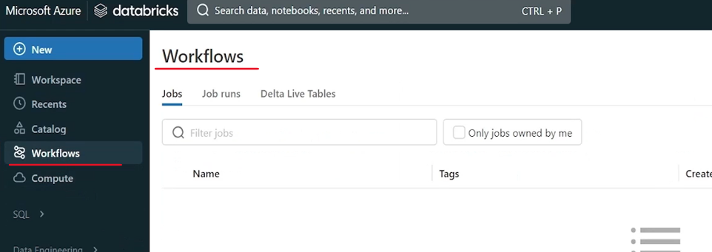

It is also available in the data engineering menu where you have Delta live tables. This will directly bring you to Delta Live Table. So Delta Live Table. Here is a UI that allows you to create the pipeline.

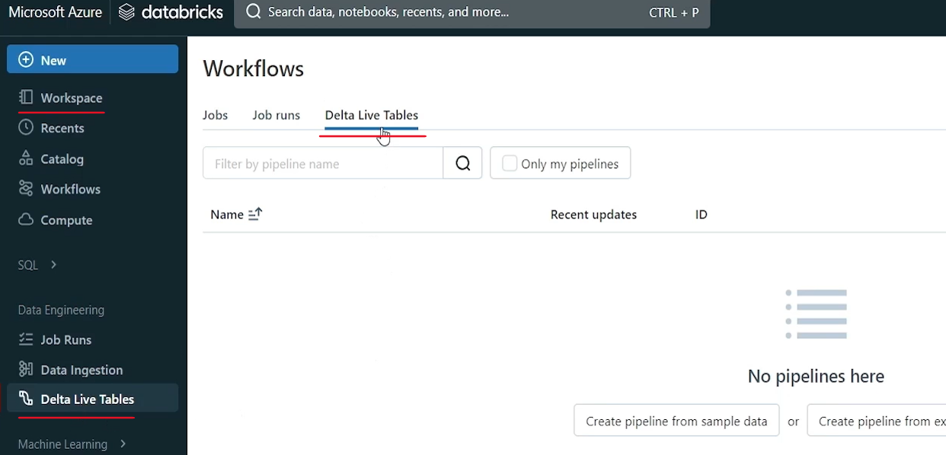

You should have done coding already. And that code could be available in your source file or in your notebook. So that is done. Let's learn how to create a pipeline and see what a Delta Live table pipeline means. So hit the Create Pipeline button. You can give a name to your pipeline.

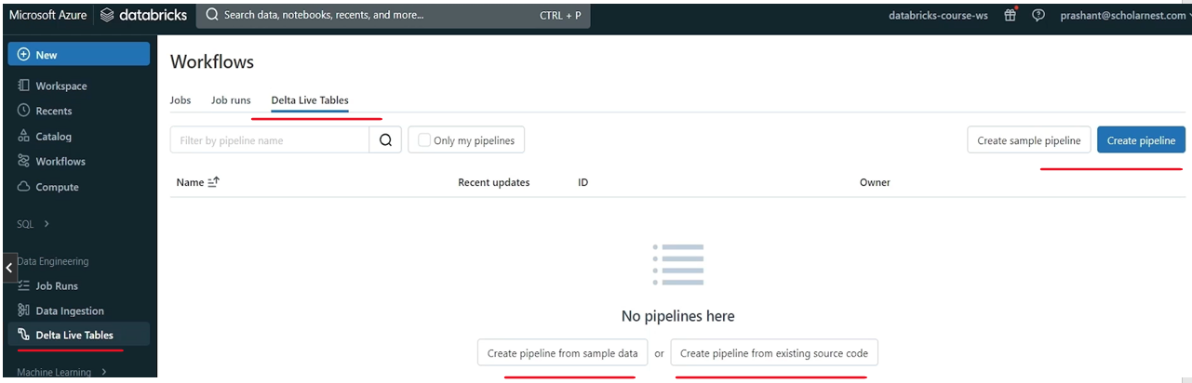

Let's call it NY, says DLT. Pipeline, whatever name you want. And, product edition. So they have core Pro. Advanced. Advanced comes with all the features.

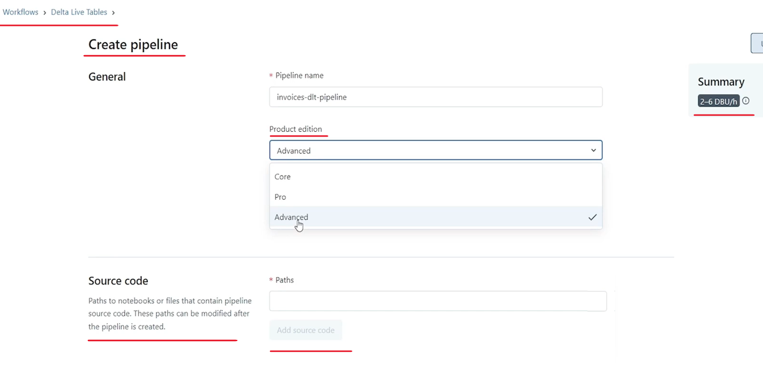

So let's go with the advanced and then pipeline mode.

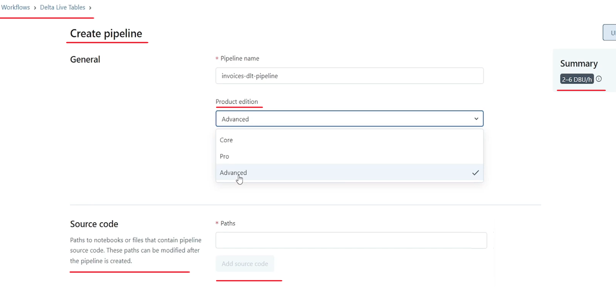

So this tells, how your pipeline will be executed. You want it to be triggered at a regular interval. Or you want it to keep on running all the time. So we want to go for a triggered one. So triggered means you can schedule it maybe every half an hour or every day, in our scenario we want to build a daily sales reports, so maybe triggering it once in a day is enough, right? So you can choose the pipeline mode.

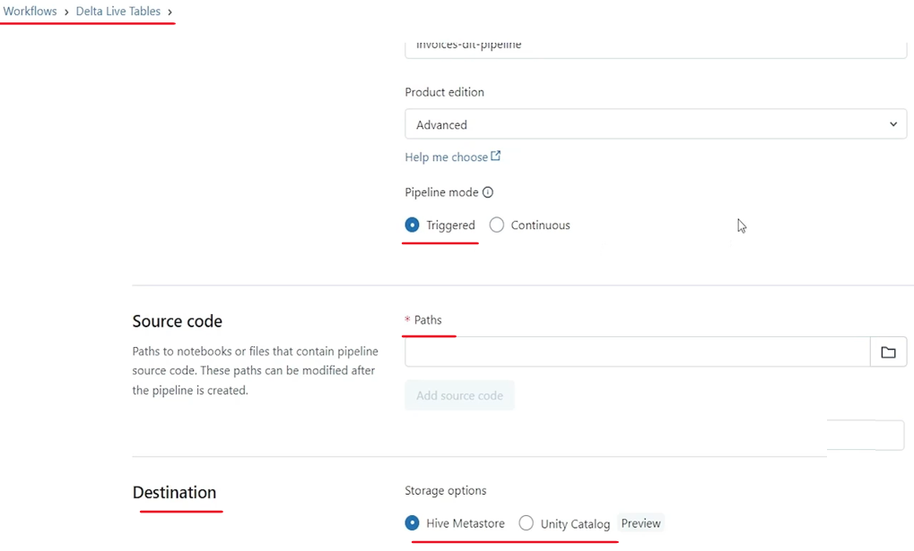

And then next step is to tell where is your pipeline code, where is your source code. So just do the browse. You can have your code in the repo or you can have in your code in the workspace. So I have in the workspace I'll simply go and choose my Delta pipeline code or the notebook. Select it. And that's all code is, done.

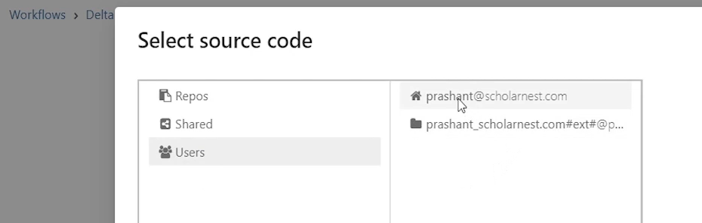

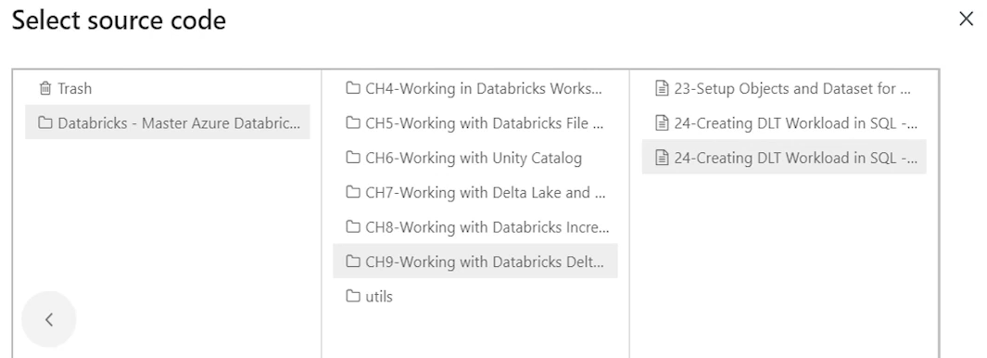

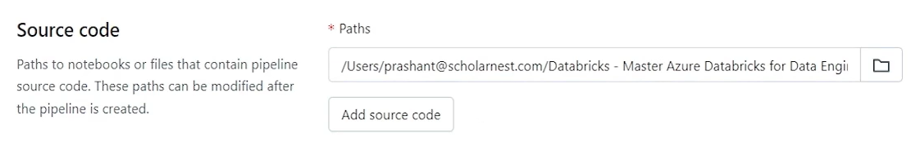

Next step is to tell where your DLT tables will be created, in which catalog or which database. So hive Metastore means your workspace, local catalog and unity catalog which is in preview mode. Earlier this feature was not there with the DLT. DLT is a tool which is in active development, and with every new release, you keep on getting new, new features. Now, Databricks is continuously improving and adding new and new features. So earlier unity catalog was not supported by DLT. So what does it mean. The target table. We are creating customers_raw table invoices_raw table. And we are creating a customers and invoices fact tables gold layer tables. Those tables should be created in a catalog and in a database. Right. So earlier DLT didn't support Unity catalog. Now you can create those objects in the, Unity Catalog object and then manage privileges properly. So choose your catalog. Which catalog do you want these tables to go. dev catalog I that's what I have. And within the catalog you choose your database. So which database I created? Demo database. Demo DB database for that purpose. So let's choose that. So my all the tables that I'm creating as part of the DLT will go and sit in this database

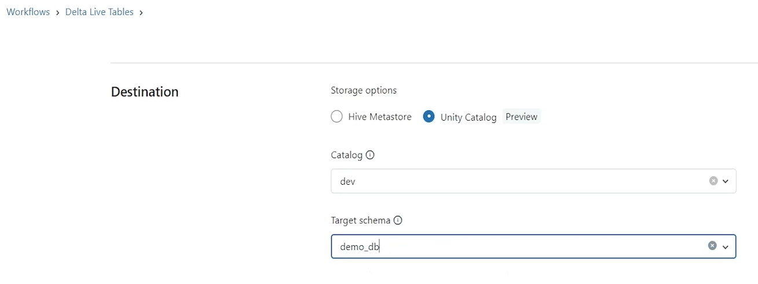

and then cluster policy. So we don't have any cluster policy none. So leave that for now. and what is the cluster mode. So cluster mode we have enhanced auto scaling, legacy auto scaling, which should go away in the future versions and fixed size. So what kind of cluster do you want for your DLT pipeline to run? Right. It's a job. It's going to run as a job.

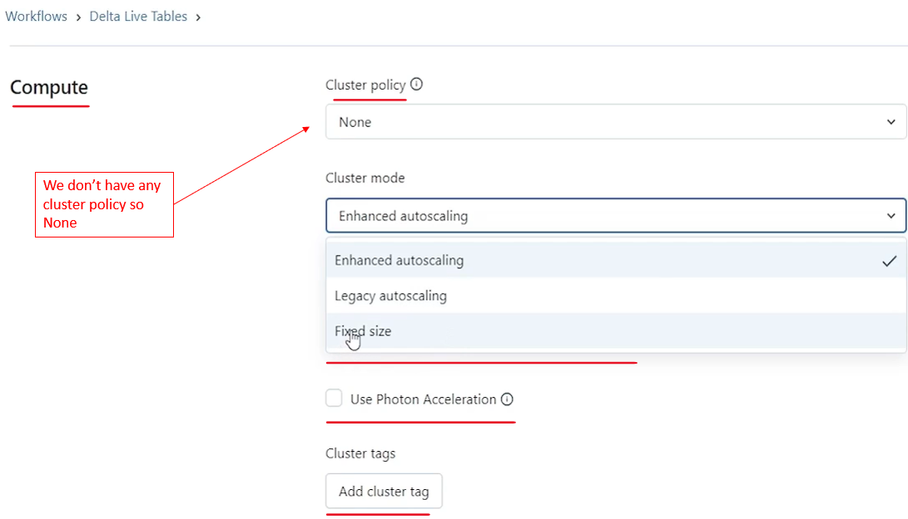

|  |  |
| --- | --- |
|  | So do you want cluster which can auto scale to a larger size depending upon the workload. Or you want a fixed size cluster. So whatever you want, you can choose. I'll go for a fixed size cluster. And what is the fixed size? Five worker nodes. That's too much for a simple, learning scenario. So I'll go with a single worker. So what it will do DL this pipeline will launch a multi-node cluster because DLT pipeline requires a multi-node cluster, with one worker and one driver. And that's how it says two DB per hour. So that's what my, cost is going to, become two DB per hour. Do I want photon acceleration for this cluster? No, I don't want. |
|  |  |

And then, other things are like notification. Do you want to configure some notification for starting for, finishing, for errors and all that? all those facilities are there. I'm not going into those details in the advance. If you want to add some additional configurations, you can add those configurations for your cluster.

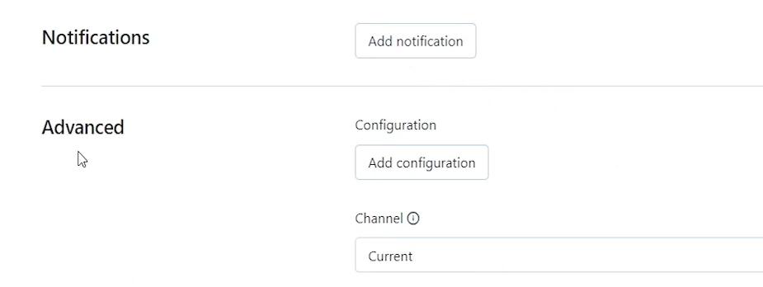

what type of channel do you want. So this is interesting. Current is whatever is, ready for production and comes with the Long Tum support. And preview channel is including those features that are still in preview. So we want to go with the preview channel, because we know we are using Unity Catalog for this scenario. And Unity Catalog is in preview. So it is kind of necessary to go with the preview channel. But maybe in a couple of months very soon, this will, this feature will also become, production ready.

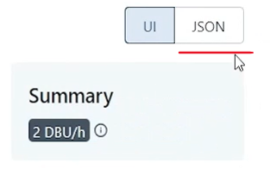

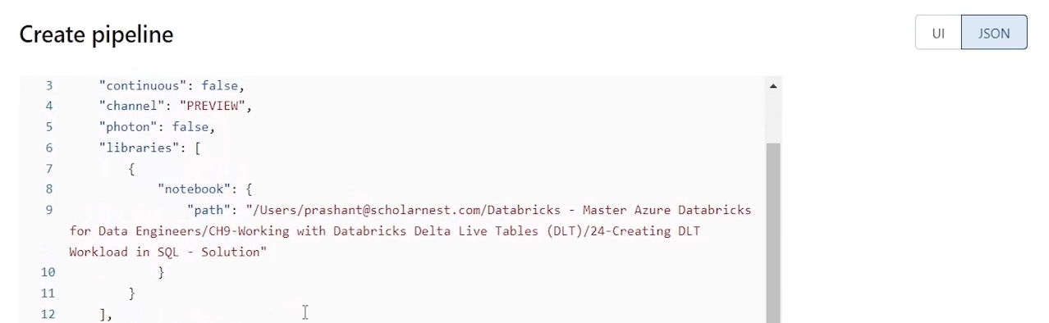

So that's all maybe you can see the UI, Json for this. And if you want to automate this using Rest, API or CLI, this is what, you can use, but go with the UI for now and hit the create button and it will create a pipeline. Right. So it's a basic pipeline. show. And this is the pipeline UI, this is where what you will see. So maybe if you want to come here again next day, you can come back to workflow, come to Delta live table and you will see the same pipeline here. Hit the pipeline and you will see the pipeline home page.

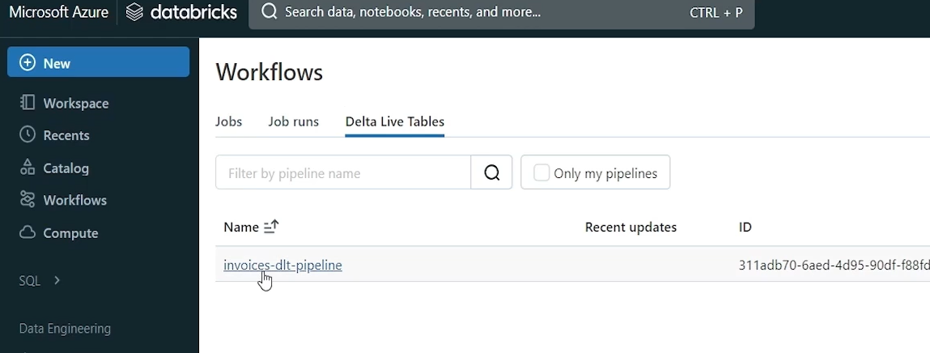

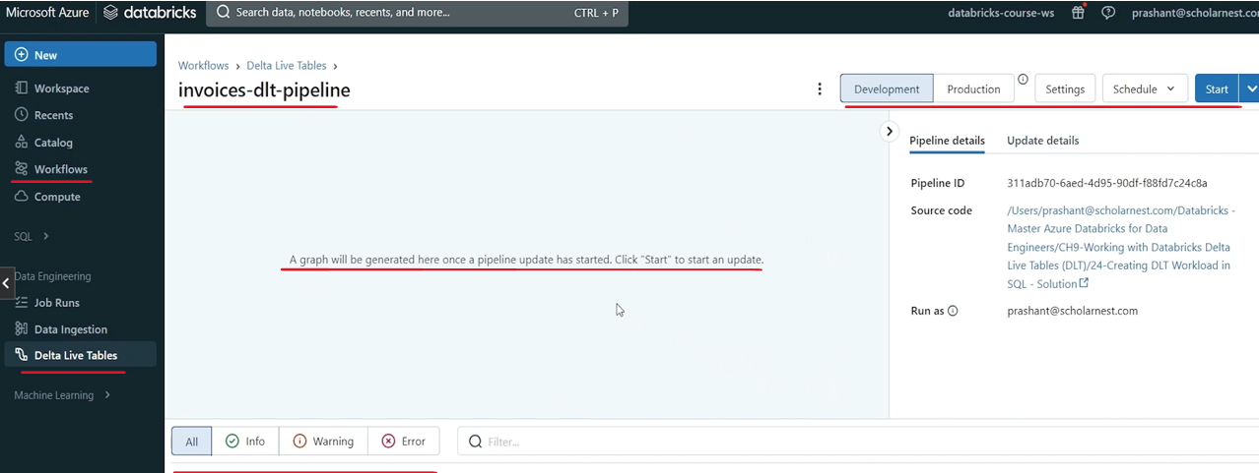

So what do we have? this is the central area where pipeline will show the entire hierarchy visually. But for that we have to run the pipeline at least once. So the entire hierarchy is shown here. Here you will see all the messages, events. What is successful, what is failing. You have the pipeline details here. Like this is the ID. What is your source code run as which user update details? cloud is Azure and product edition is advanced. So and you can see two tabs here development tab and production tabs. So they have prepared two modes actually. So this is production mode and this is development mode. So we are in the development mode. So I'll go for the development mode. But once your pipeline is developed tested, you set it to production mode and then run it. And if you want to see some settings are here, you will come back to your, page, the creation page, all the settings. You can change it from here, cancel it and come back here. And then, we have an option to schedule things. Right. So if you want to schedule, you can add a schedule. And add schedule will allow you to run it at a regular frequency. That's simple. Maybe. Let's try it. So what is your schedule? Let's give a unique name for your job. Delta job. Do you want manual or you want, automated schedule. What is the frequency? Every minute, every hour, day, month, all that you can schedule and set the alerts for start, success, failure, all that.

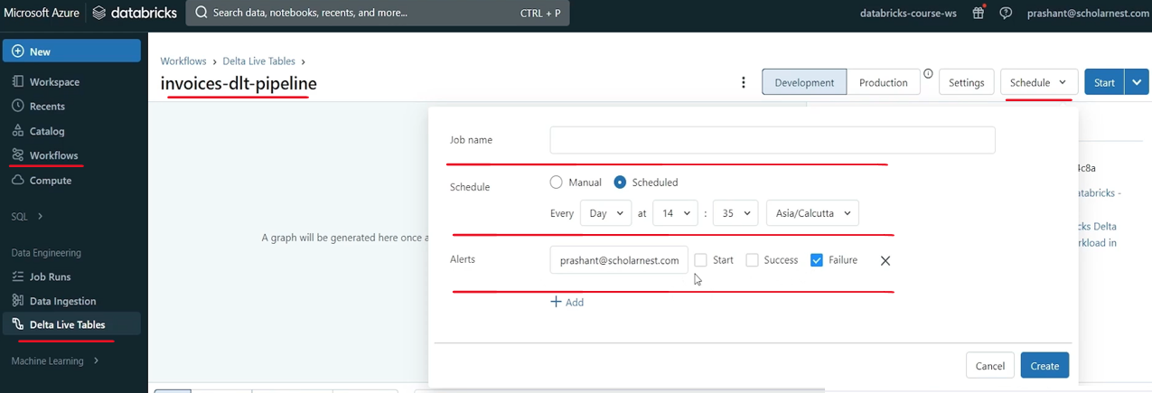

We are still in the development phase, so I don't want to schedule it, but you have an option to schedule this pipeline, and it will keep on running at a regular interval. you can start it from here. So we have two modes for start, full refresh all and then validate. Validate will simply you already have the code will go look at the code and try to validate it. So you have two modes. So let's run it in the full refresh mode. This is first time we are running this DLT pipeline. So it should be full refresh mode.

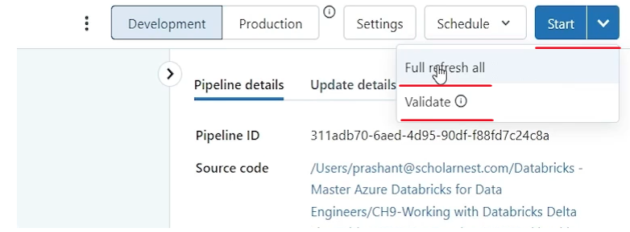

So let's run it. hit the start button and it will start. These are the steps that it is going to perform.

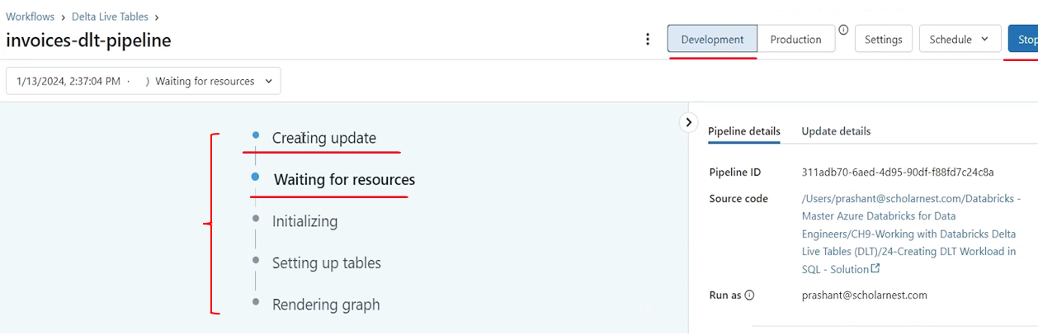

And it's a job right. DLT pipeline will create a job, and run your, code that we defined, in the notebook. So for running that job, it is first step is to create a cluster. So basically it is waiting for resource in the background. It has launched a job cluster a DLT cluster. Once that cluster is ready, the job will start executing. Maybe if you go to compute menu you can come to compute menu. This is my multi node cluster that I created earlier.

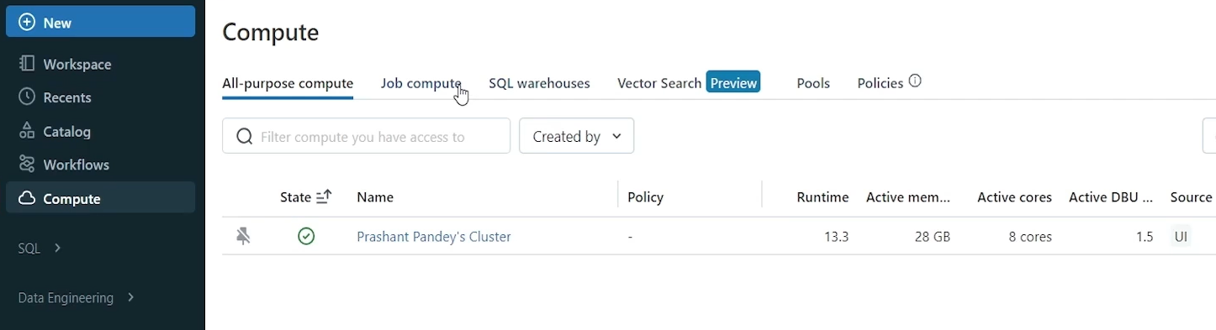

If you come to job compute you will see a DLT execution ID blah blah blah. There is one job cluster being launched.

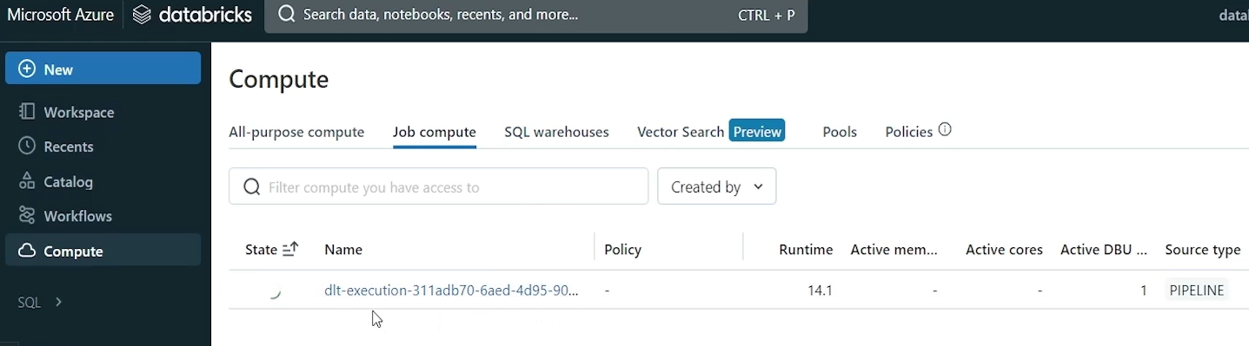

Its state is still starting. So and you can see here the pipeline is waiting for the resource. So it may take some time to start the cluster and finish the job. So I will pause the video and come back when my cluster is ready.

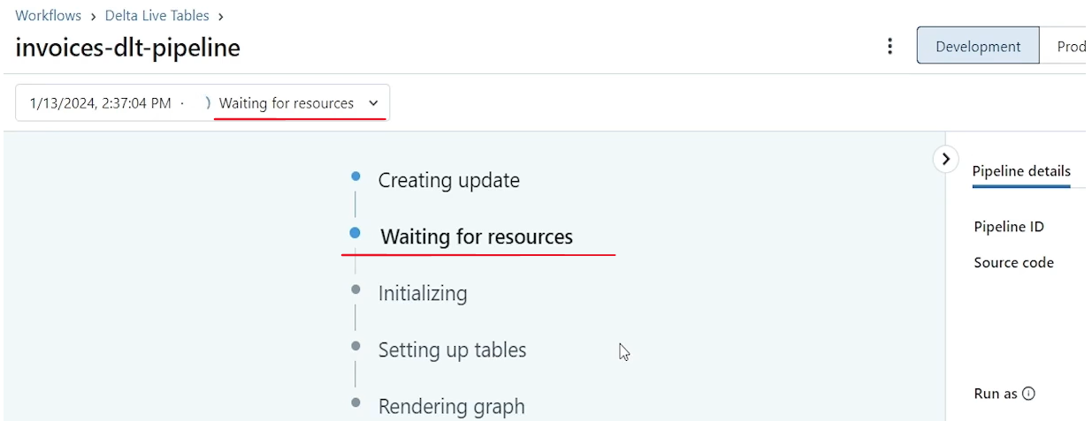

And, job is supposed to start doing its work, so I'll come back. So my cluster looks like it is started and it's moved to initializing stage and my pipeline is running. I'll see all the events here. If something fails, I should see the failure message. If everything, the entire pipeline works smoothly. I should see a bunch of success messages here. So maybe you can expand it a little bit.

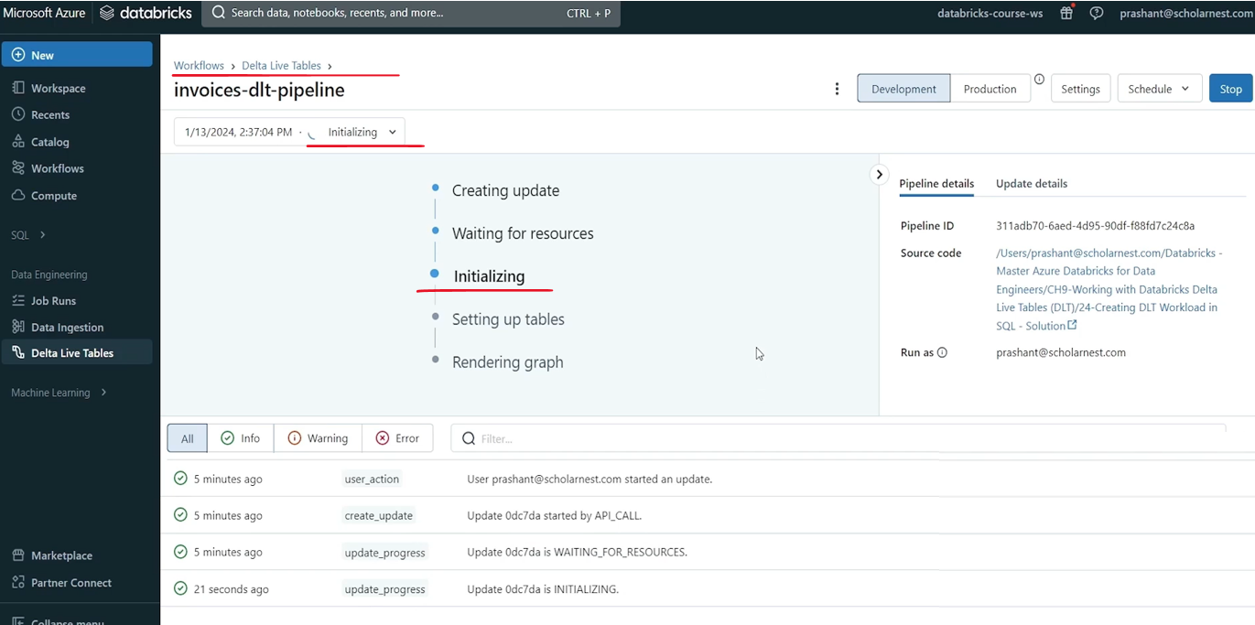

Okay, so it looks like it's in the final stage of running. All the setup is done and we can see these four tables are refreshed. Now these two are getting refreshed. maybe I can zoom out a little. Move it here so you can see the entire pipeline.

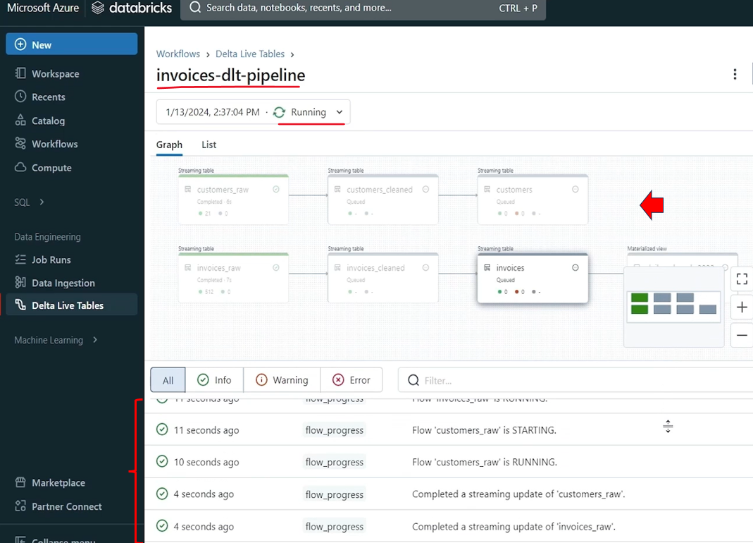

So these two are currently refreshing. All done. I think this one is refreshing. Now all these are done. So all the dependency is automatically identified, based on our code. And we see a nice visualization here. And it looks like it's completed.

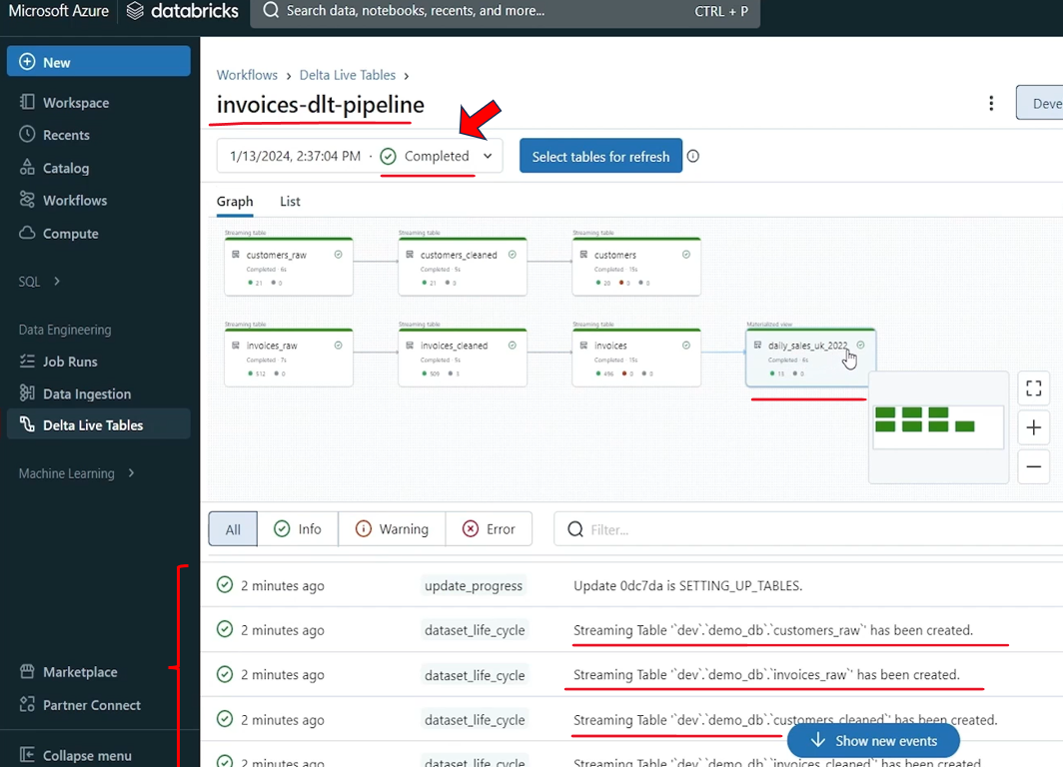

Everything worked perfectly fine. And if you see update details here, is updated, status is completed and update type was refresh all creation time duration this including the cluster start time one minute 41 second is the runtime. This is the compute resource. So all that details are here. So it worked. It worked. Now let's go back to my workspace and open my setup. script. We earlier we created this setup script. and basically we ingested some data files, in the landing zone, and we stopped here. Right. Create and run your dldt pipeline. So I've done creating DLT pipeline, running that DLT pipeline. And once this is done, my final result should be here, right? Daily sales UK 2022. table should have the final results. So can we query that table so you can query that table. And that table should have been created into the dev catalog demo DB database because that's where I, created it. So we do have results. result is calculated. This table is populated. Maybe if you want to describe this table, and see, what kind of table it is, let's do describe extended and describe this table. you will see some more details about the table.

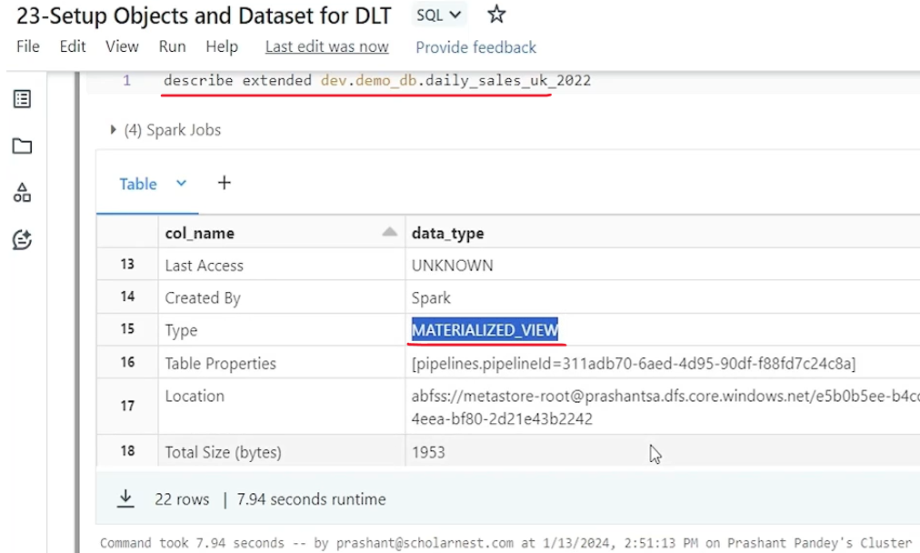

So a schema of the table. Let's create it in the demo db database table name is this and table type is Metalized view. Because that's what we wanted right? We created a live table. So it's a Metalized view right. So that's all about this maybe let's come and see a few more things in the report here. So if you look at if you click any of these, tables, you will see some more details here.

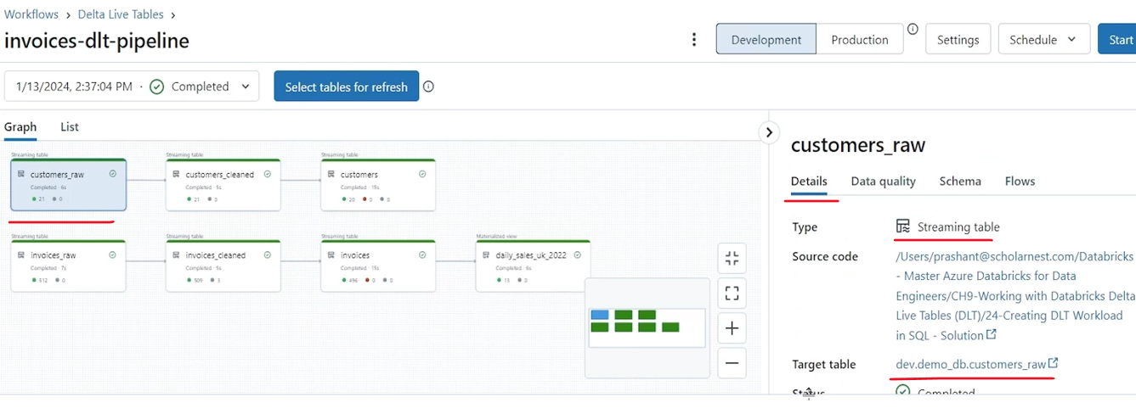

So let's let's see what do we have. So this table you can see details from here itself. It's a streaming table. Right. And then status is completed. Target table is, raw. That's what we have. If you look at the data quality you will see what is the data quality for this table. So we didn't implement any data quality rule on this table. So everything is like 100%. But on the customers cleansed we implemented data quality rules. Right. We implemented expectation. So 100% return, nothing is dropped. Right. And this is the validation, valid customer validation that we defined, 0% failure. Maybe look for the invoices data quality. And there are three records were dropped, because either, of the two fields that we defined in the validation, this validation failed. Right. So the, return is 99.4% dropped is 0.6%. So you get the details about the data quality from here. maybe if you want, you can close this, make some more space. You get the schema here, and flow tells, what type of flow this table will implement. So it's an incremental because it's an streaming table. Right. So this invoices is, based on change because we implemented merge statement. Apply change. Right. So it's a change. What about this. So this is also a change, because we implemented apply change for this. And this one is a complete refresh. It tells it's a complete refresh. If you look at the details, it will tell it is a metalized view. But this one is a streaming table, right. So that's how, Delta Table Pipeline gives you a lot of reporting capability and monitoring capability. but what about the increments? Right. So let's go, and ingest some more records into the landing zone and see how it refreshes the second iteration. So, I'm going to copy another, customer data set and three invoices, data sets in the landing zone. So let me run that. So simply, I'll copy some more, records into the landing zone to simulate the ingestion. So we ingested some new data into the landing zone and run that, run this, run this also. And then run this also. Right. So we ingested a bunch of new files, some new customer information, some new invoices. ran the pipeline once again. So you come here. I have not scheduled it to run at regular intervals, but if we have done the scheduling, it should automatically run at regular intervals. But, I can hit the start button from here, manually. Now, if you see there is a full refresh all option. So if you click that, then the entire pipeline will do a full refresh. Full refresh means it will go back and start reading, raw data from the landing zone, and do everything from the scratch, all the data, it will again start consuming once again, but we don't want full refresh default. If you hit the start button, it will do an incremental refresh. So let's hit the start button. And it will automatically, start at this time. I don't have to wait for the cluster because my cluster is still running, that I created earlier. So now it is going to refresh. It should be done, much quicker. These two are refreshed now. These two are running, rest. All is in queue. completed. Now. This should be running. So this is completed. if you look at this, these two are now refreshing. And finally, this is, planning and then running. this will be refreshed. Done. So now, if you come and look at the details, data quality 100% here. but if you look at the invoice, cleansed, data quality 100%, this time we didn't drop anything, right? customer cleansed, 100%. This time there was no drop. Right? And, yeah, look at the flow. The flow is incremental, and this one is complete. So this one is a metalized view. So it will be refreshed every time. Maybe you can come back to your notebook and look for, results once again in this. And now we have 15 rows earlier we had 13 rows. So it looks like some new aggregates are calculated, and maybe the old ones might have been updated. Also, we implemented SCD type two for the customers table. Right. So let's look at this particular customer ID in the customers dimension table. how am DLT has implemented the SCD type two. So I have prepared update in my data for this. So here it is. So let me scroll up a little. So what is the customer. Customer ID is same 15311. Define and define Travolta. So and we have start and end right. And we also have a load time. So this record is started on 13th January 2024 and maybe at 913 and ended at 926. So. Then we got one update. maybe the name was updated. from defined to define Travolta. So we got an update, and that update becomes the new active record for this customer. Right. And this starts from nine 2621. It's the exact time when this guy becomes inactive, right? So it starts from here and end date is null. It means it is currently active record. So pretty good right. So it implements a CD type to automatically, all the complexity is taken care of. And that's all about, DLT pipeline. Hope you learned, how to build DLT pipeline, do things quickly using Databricks DLT. One last thing. If you are following along, you are trying this. What, I've been doing here. and you, once you are done, don't forget to delete your DLT cluster. So go to your compute menu like this. And the jobs, job compute. You will see your DLT cluster, which is running. So usually this, you might forget to delete that or clean up that which will cost you unnecessary money. So come to this and maybe in the more, you have the delete option. So delete the DLT cluster and also keep on deleting your, all purpose clusters, whatever you are creating for your learning exercises. Once you are done, don't leave it running for a long, which might incur unnecessary cost.